INTRODUCTION

My is Gajendra I am from Kanpur I have 4 years of expeience in testing domain most of in manual and automation
I have collaborate with dev team and product owner and busuness analyst team to discuss the requirement and high level senerios
I worked on banking domain in my previous company qualtech consultant pvt ltd and in my current company I’m working in logistic domain packers and removers
My responsibilities include conducting sanity, smoke, regression, and UAT testing, along with test planning, test case design, and requirement analysis

(MANUAL TESTING & AUTOMATION TESTING)

MANUAL TESTING – Manual testing is a process of testing in which the test cases are executed manually without using any automated testing tool. Manual testing is mandatoary for every newly developed software before automation testing.

AUTOMATION TESTING- In automation testing the test cases are executed with the help of test script here we use tools in automation testing. it is effective and time saving in automation testing time-saving

Que-1 What is SDLC ?
Ans-1 SDLC stands for (Software Development Life Cycle) SDLC provides a structured approach for developing software. This process which ensures that the entire process follows a systematic and organized path.
SDLC CONSISTS OF VARIOUS PHASES.
REQUIREMENT ANALYSIS >DESIGN>CODING>TESTING>DEPLOYMENT>MAINTENANCE
Requirment > Feasibility Study <(TELOS –T-technical feasibility E-economical feasibility L-legal feasibility O-operational feasibility S-time schedule feasibility)

COMMON SDLC PHASES:
Planning: Defining the project scope, goals, and resources.
Requirements Analysis: Gathering and documenting user needs and requirements.
Design: Creating the software architecture and design specifications.
Coding/Development: Writing the software code.
Testing: Verifying and validating the software functionality and quality.
Deployment: Releasing the software to end-users.
Maintenance: Providing ongoing support and updates to the software.

Que-2 What is STLC ?
Ans-2 STLC stands for (Software Testing Life Cycle) STLC is a systematic approach to test software to ensure that it meets all the requirements.
STLC CONSISTS OF VARIOUS PHASES
1.Requirement Analysis :-In this phase, the testing team analyzes the requirements provided by stakeholders to understand the software’s functionalities, features, and expected behavior.
2. Test Planning :-A detailed test plan is created once the requirements are understood. This plan defines test objectives, scope, strategies, resource allocation, and timelines.
3. Test Case Development:- Test cases are designed based on the requirements and test objectives defined in the previous phases. These test cases outline step-by-step instructions to validate different aspects of the software.
4. Test Environment Setup:-A suitable testing environment is set up with all necessary hardware, software, and network configurations to execute tests effectively.
5. Test Execution:- the primary goal of test case execution is to execute test cases and verify the result and defects or deviations from expected behavior.
6. Test Cycle Closure:- After the test execution phase, the test cycle closure involves analyzing the test results, documenting lessons learned, and preparing a final report to evaluate the overall testing process.
REQUIREMENT ANALYSIS – (Test Planning).
TEST DESIGN –(To set the environment).
TEST CASES DEVELOPMENT –(Test case/Test script).
Execution of test cases.
Test cycle closure.

Que – What is traceability matrix ?
Ans - A Traceability Matrix (TM) is a document that maps and traces user requirements with test cases. It helps in validating that all requirements are covered by test cases, and nothing is missed during testing.

Que-3 what id JIRA?
Ans-3 The most regularly used bug-tracking tool is Jira. Jira is an open-source tool. It is used for bug tracking, project management, and issue tracking. this is a tool we can easily track all kinds of bugs and defects related to the software.
Features of JIRA
- It is a time-saving tool.
- Jira is used to track the defects and issues.
- It is used to establish the documentation tasks.
- Jira is a very useful tool in tracking the improvement of our documentation.
Que-4 What is software testing ?
Ans-4 Software testing is a validation process that confirms that a system works as per the business requirements. It qualifies a system on various aspects such as usability, accuracy, completeness, efficiency, etc. ANSI/IEEE 1059 is the global standard that defines the basic principles of testing.

Que-5 Mention the different types of software testing?
Ans-5 Various types of Software Testing used by manual testers are as follows.
- Black Box Testing
- Regression testing
- Smoke testing
- Functional testing
- Exploratory Testing
- Integration Testing
- System Testing
- User Acceptance Testing (UAT)
- Alpha and Beta testing
- Unit testing
- Integration testing
- Performance Testing
Que-6 What is positive testing and negative testing?
Ans-6 Positive Testing -It is a type of testing process where a software application is validated against the valid data sets as input. It is simply used to check whether or not the application does what it is supposed to do.
Negative Testing - It is a type of testing process where a software application is validated against invalid data sets as input. It is simply used to check whether the system shows an error when it is supposed to do or not. In test case execution, negative testing is considered a very crucial factor.

Que-7 What is sanity ?

- Sanity Testing :- Sanity testing is used to verify the specific functionality after receiving a stable build with minor change or bug fix.
To verify that specific functionalities or bug fixes work as intended after changes have been made.

Ans-7 Sanity testing is used to validate the changes made to one or few specific parts of the application to make sure that the software is still functioning as expected after a small change or a bug fix

Sanity Testing is carried out to check and confirm that the functionalities are working perfectly after minor functionality/bug fixes or any changes.

Que-8 What is regression Testing?
Ans-8 Regression testing is a black box testing.it is used to authenticate a code change in the software doesn’t impact the existing functionality of the product. Regression testing is making sure that the product works fine with new functionality , bug , fixes , or any change in the existing feature.it is used to ensure that any change in a product does not affected the existing module of the product .

Que-9 What is test cases ?
Ans-9 A test case is used to define a group of conditions under which a tester determines whether a software is working as per the requirement or not. Test case design includes test case id, test case name, pre-conditions, and expected result. A test case is the first level of action and is derived from the test scenarios.
There are different types of test cases which are as follows:
- Functional test cases
- Integration test cases
- System test cases

Que-10 Java conceptual diagram ??
JDK -Java development kit (To develop and run the java program).
JRE –Java run time environment(To run java programs)

Que-11 what is class in java ?
Class- A class in Java is a set of objects which shares common characteristics/ behavior and common properties/ attributes. And the class name always start with capital letter or upper case.

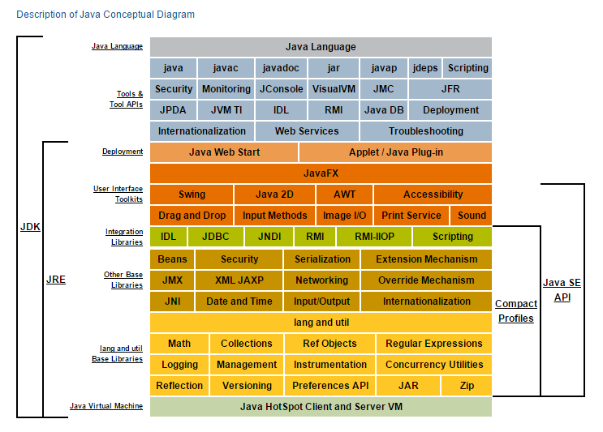

Que-12 What is api testing ??
Ans 12 Application Programming Interface (API) testing is a software testing process that verifies an API's functionality, reliability, performance, and security. It involves sending requests to the API and checking the responses to ensure they match the expected results. It involves testing the logic performance , reliability and security of api’s without a user interface.

USE OF API’S TESTING
1.Valadting business logics
2.Testing data accuracy and formate
3.Early testing without ui
4.Early bug dedection.
5.Time and Cost effective.
FEATURES OF AN API

1.FASTER TESTING :-No need for ui, east to automate.
2.EARLY DEFECT DEDUCTION :-Tests run before Ui is ready
3.BETTER RELIABILITY:-Less prone to break than ui tests
4.IMPROVED SECURITY :-Find critical securities flaws
5.BROAD COVERAGE :-Validate core logics , integration and errors.

MAIN COMPONENT OF AN API’S
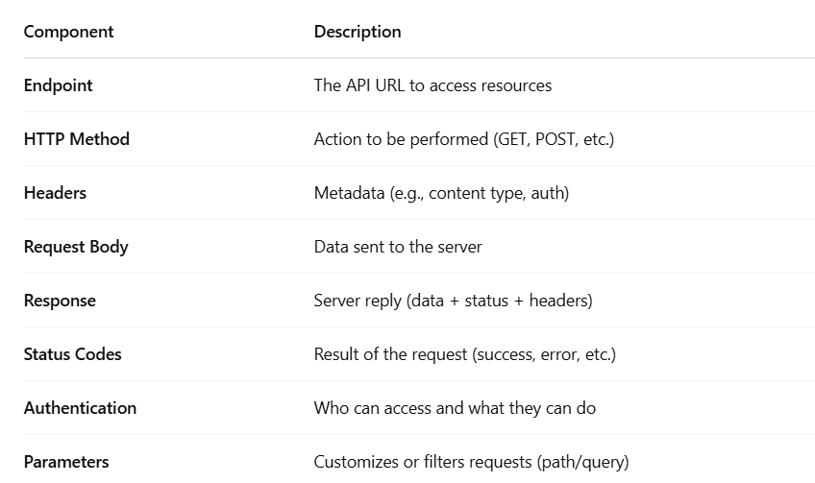

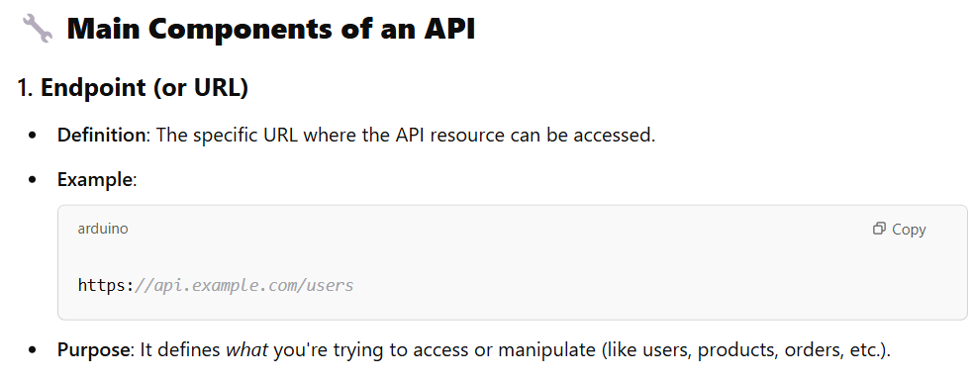
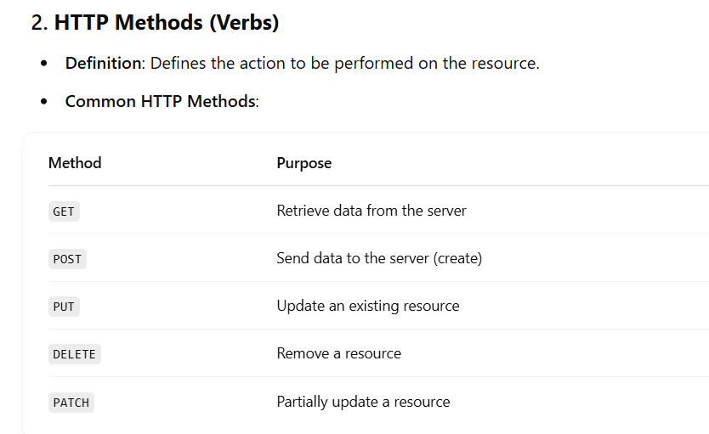
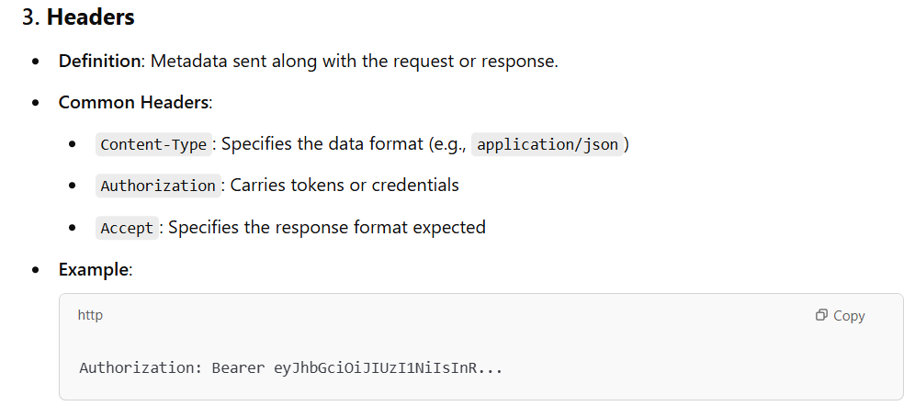
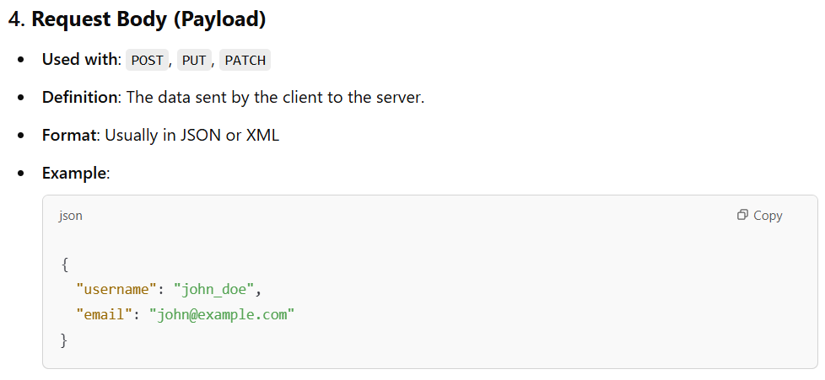
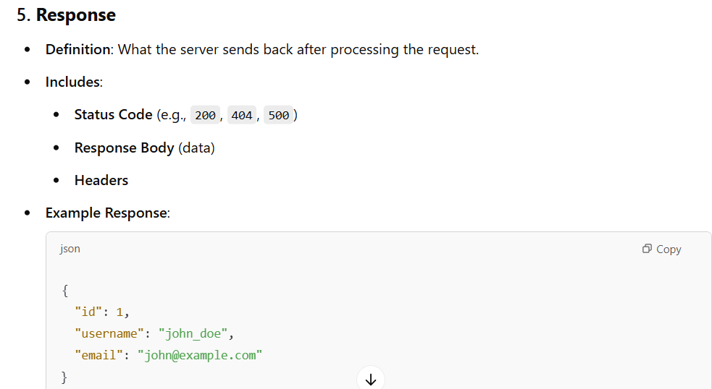

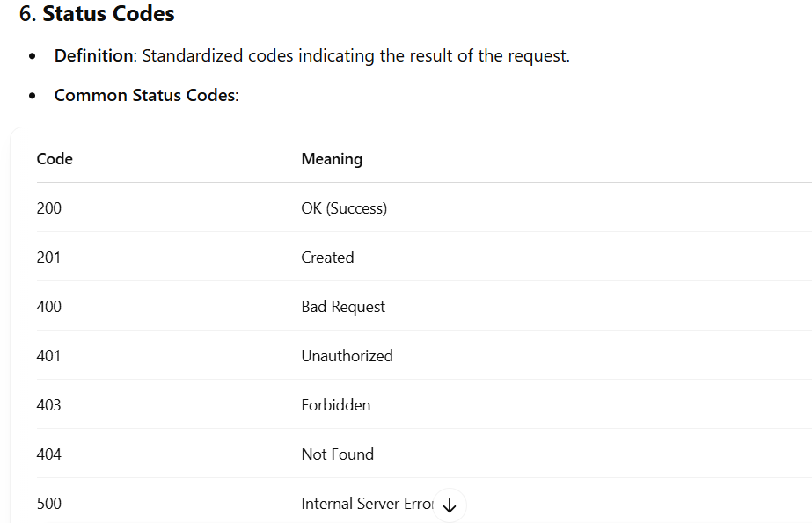

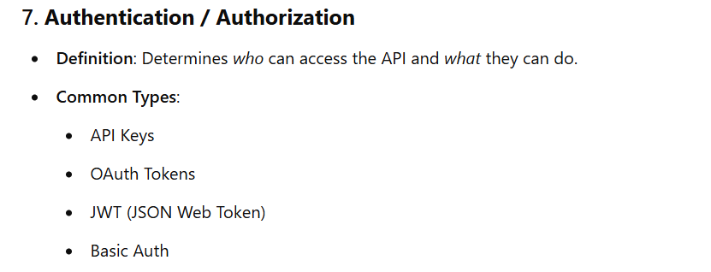

Que – What is bearer token ?
Ans – Bearer token is a access token for authorization it is just like a string with Alphanumeric.
Que – What is the meaning of complete URL and define all parameters ?
Ans –
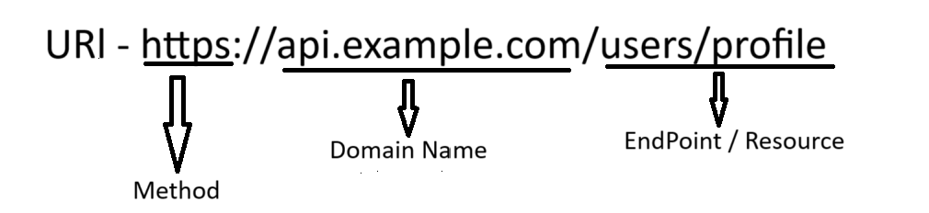

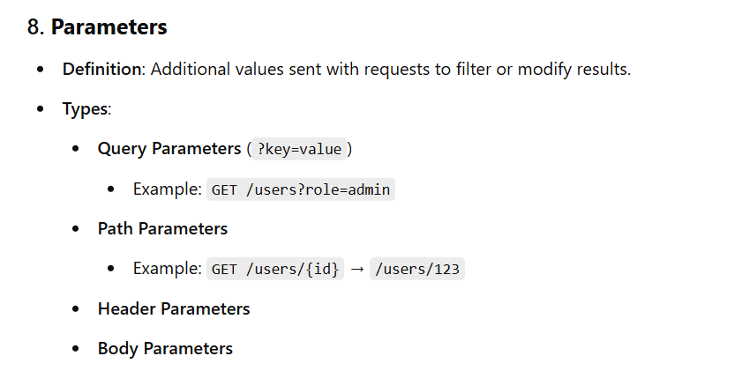

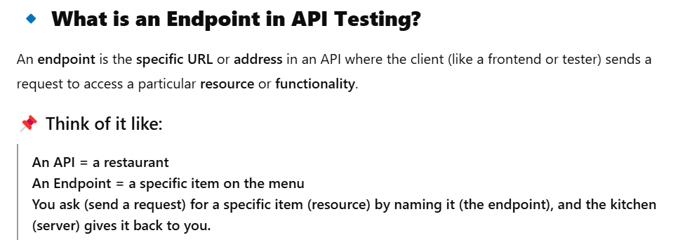
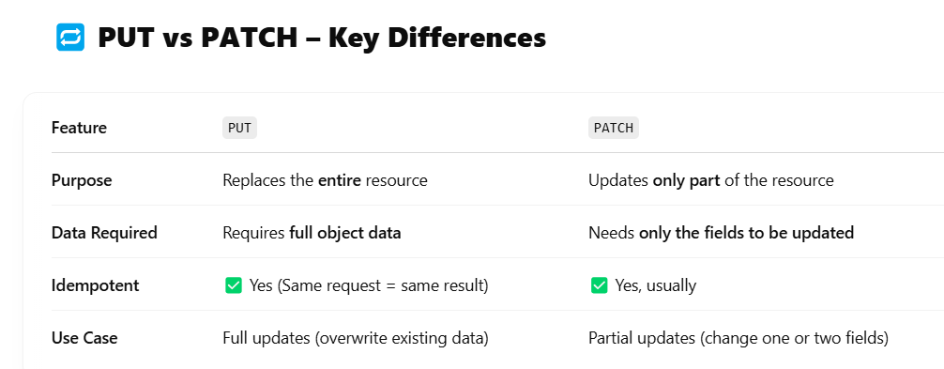

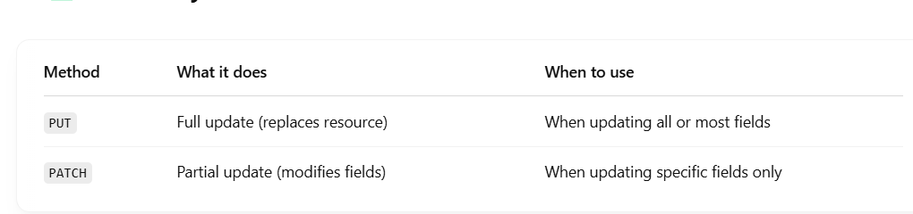

Que - What is the Use of cURL ??
Ans - cURL (Client URL) is a powerful command-line tool used to transfer data to or from a server using various protocols, mainly HTTP/HTTPS, which makes it ideal for API testing.

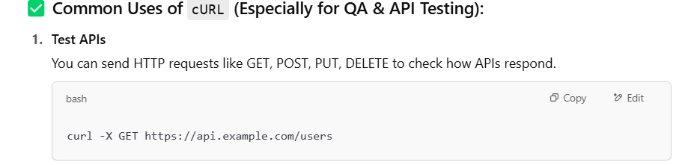

Que-13 Why do you want to change your job ??
Ans-13 I’m switching my job because of the carrier growth.

Que-14 What is mobile testing ??
Ans-14 Every developed mobile application has to go through the mobile testing process. This process assures us to maintain the level of the quality of the application before it is released into the market applications are tested based on usability, security, functionality. This increases the general efficiency of the application and increases the reliability factor among the users as well.mobile App Testing refers to the process of validating a mobile app (Android or iOS) for its functionality and usability before it is released publicly. Testing mobile apps help verify whether the app meets the expected technical and business requirements.

Que-15 What is the difference between mobile testing and web testing ??
Ans-15 WEB TESTING --Web app testing is the process of testing web-based applications to ensure that they meet the required quality standards and function as expected. Web apps are software programs that run on web servers and are accessed through web browsers such as Google Chrome, Mozilla Firefox, or Microsoft Edge.
MOBILE APP TESTING--Mobile app testing is the process of testing mobile applications, which are software programs designed to run on mobile devices such as smartphones, tablets, and smartwatches. Mobile app testing is essential to ensure that the app is functional, responsive, secure, and user-friendly.
Web applications and mobile applications have different characteristics, and therefore, their testing requirements and approaches are also different.

PURPOSE OF MOBILE TESTING
• To verify that the mobile app works as expected
• To ensure the app performs well on different devices, operating systems, and networks
• To find and fix bugs or usability issues before releasing the app to users
TYPES OF MOBILE APPS TESTED :-
Native Apps – Built for a specific OS (e.g., Android or iOS)
Native apps are developed for the specific platform like (ios , android windows)
Web Apps – Accessed via mobile browsers it runs inside the browsers (chrome, Mozilla, safari)
Hybrid Apps – it is a combine native and web applications it is easy to developed and cheaper to maintin
How do you perform mobile testing manually?
Answer: By installing the app on different devices or using emulators/simulators, and then testing features like login, navigation, gestures, performance, and handling interruptions like calls or messages.

7. What challenges do you face in mobile testing?
Answer:
- Device fragmentation
- OS version variations
- Network issues
- Handling different screen sizes and resolutions

SENERIOS BASED MOBILE TESTING QUESTIONS ?

Que --How do you test an app in poor or no network conditions?
Ase --To check how the app behaves when the internet connection is slow, unstable, or completely unavailable.

Common Methods:
Airplane Mode / No Network:
Turn on Airplane Mode on the mobile device.
Open the app and try actions that require internet (e.g., loading a feed, logging in).
Check: Does the app show an error message like "No Internet Connection"?

Using Network Throttling (Realistic Simulation):
Use developer tools or network link conditioners:
iOS: Enable “Network Link Conditioner”
Android: Use emulator or third-party apps like Charles Proxy or NetLimiter
Set it to 2G/3G or simulate packet loss/delay.
Use the app and observe:
Is the app slow?
Does it retry automatically?
Is user data saved offline and synced later?

📱 Real-world Example:
App: Food Delivery App (e.g., Zomato or Uber Eats)

Scenario:
You’re placing an order in a place with poor network.
Test Steps:
Turn on “Airplane Mode” or simulate 2G network.
Try to:
Open restaurant list
Place an order
Expected Results:
Shows a “No internet” warning
Prevents incomplete order submission
Saves the cart locally (optional)
Automatically retries when network is back

How It's Done
- Manual Testing – Testers use the app on real devices or emulators
- Automated Testing – Scripts run tests automatically (e.g., using tools like Appium, Espresso, XCUITest)

Platform: Web applications are accessed through web browsers, whereas mobile applications are installed on mobile devices. Therefore, mobile app testing requires testing on multiple platforms, such as iOS and Android, whereas web app testing is usually limited to testing on different web browsers.

Que -16 What is functional testing ?
Ans – Functional testing is the type of software testing in which the system is tested against the functional requirement and specification in this we test all the functional requirement rather than internal implementation in this testing seeks to established whether each application feature works as per the software requirement.

In functional Testing, the quality engineer confirms whether the application features work based on specific requirements. This Testing can be done manually or through automated tools based on the specific test case.

Que --What Is Non-Functional Testing ??
Ans – Non-functional Testing evaluates the software application’s performance, dependability, usability, and other non-functional characteristics.

There are different types of functional testing.
- Unit Testing –In unit testing test individual unit of code to make sure they work as expected unit testing is done by the developer during the development
- Integration Testing –in integration testing is a type of software testing in which the different modules or component of software applicant are tested as combined entity is known as integration testing .
- Smoke testing – a smoke testing is a type testing that which is also called the build verification testing it is verify to test the critical functionality and also we check the stability of a new build or code change and an ensuring the build is stable for further testing. And smoke testing is a high level testing it is a normal health checkup only for critical functionality
- Sanity Testing – Sanity testing is a details testing to verify the the functionality it is a deep drive testing and it would take much time to test the functionality details round of testing
- White box testing – White box testing we test the internal structure of a system or component and whitebox testing is also known as code based testing in this we should the developer
- Blackbox Testing –In black box testing we test the functionality of the system without knowing it’s internal structure in this there is no need to have an understanding of programming language. Black box testing is also known as the behavioural testing.
- Regression Testing – Regression testing is a type of testing process to ensure the the existing functionality should not affect after the code change or bug fixed . in regression testing is to ensure that new changes do affect the existing functionality.
- Usability Testing –Usability testing is testing which performed in the initial level of designing phase. Usability testing is a method for evaluating the functionality the product, website, or app it for the better user interaction provide product
- Security testing evaluates software for vulnerabilities to prevent unauthorized access, data breaches, and other threats. It ensures confidentiality, integrity, availability, authentication, and authorization of systems
improvements.

Examples -

Que- 17 What is the
?
Ans -User Acceptance Testing (UAT) is a software testing phase where end users test a product in a real-world environment to ensure it meets their needs. It's also known as end-user testing or beta testing.UAT is usually the final stage of software development.

Que – What is Bug/Defect Life Cycle?
Ans –Bug life cycle performed by developer and tester both. The bug life cycle is essential for maintaining software quality.
THERE ARE DIFFERENT STAGES IN BUG LIFE CYCLE.
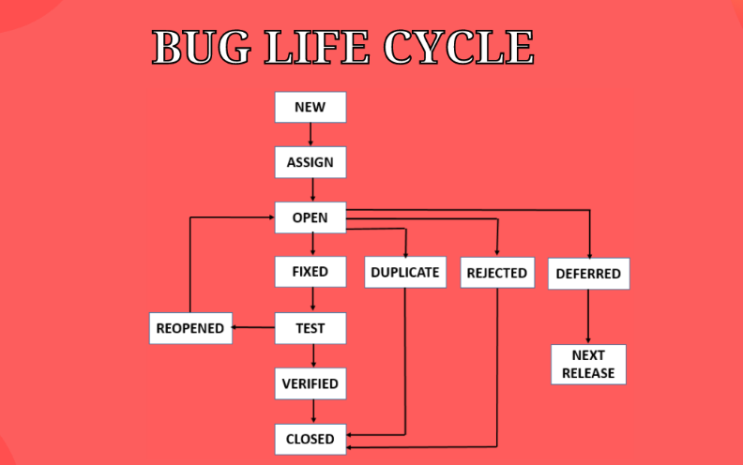

1. NEW – A Bug is identified and report for the first time.
2. ASSIGNED – Bug is assigned to the dev team for the resolving purpose.
3. OPEN – After assigning to the dev team the dev start working on the bug to check whether the bug or defect is valid or invalid if the bug is valid then they will start to fixed it and if it the bug is invalid at that time they transferred those bug into three states Like – Duplicate, Reject, Deferred.
DUPLICATE – If bug is repeated and send twice.
REJECT– If bug/defect is invalid.
DEFERRED – Sometime defect is not of a high priority and is expected to get fixed into the next release.
4. FIXED–In this the defect/bug is fixed and ready for the testing. If the bug is valid here the dev will take the action and resolved it and send to the tester to test.
5. TEST – The testing team will check whether the bug has been fixed of not.
6. RE-OPEN – If the defect/bug still exist even after dev team has fixed the bug we will mark it as Re-Open.
7. VERIFIED – The tester re-test defect again and the Qa team confirm that the bug has been successfully fixed.
8. CLOSED–The bug is officially closed and marked as resolved.

Que – What is Agile Methodology?
Ans – Agile methodology is a project management and software development approach. It is the latest model used by major companies today. This is a project management technique that breakdown projects into smaller task known as sprints.
Advantages of agile methodology.
- Ability to manage changing priorities.
- Increase project visibility.
- Improve business it alignments.
- Flexibility to change.
- Customer satisfaction.
- Better team collarabration.
- Improve quality and faster delivery.
- Faster Delivery
- Improved Quality
THERE ARE DIFFERENT TERMINOLOGIES IN AGILE METHODOLOGY.
- SPRINTS – Sprint is a just cycle of time intervalsand its helps item delivery high-quality work faster and more effectively two weeks are count in a sprint.as per companies it is varying different intervals also. A fixed timebox iteration Usually (1-4 weeks) where a usable product increment is developed.
- SPRINT PLANNING MEETING – In this methodology here we are planning what we need to do further to developed a software.
- DAILY STANDUP MEETING–In this meeting you are basically required to what work you did yesterday and what work you are going to do today and this meeting is usually done in the morning.
- SCRUM MASTER – A person who is leading the scrum is known as a scrum master scrum master is responsible to monitor the stories of each and every individual and proper update from them.
- SPIKE –Spike a such a term which is used when you don’t have any clarity about the requirement.
- STORY POINT – The basic purpose of the story point is used to define the amount of time required to do a particular work.
- EPIC –In agile, an epic is a large body of work that is broken into smaller user stories. An epic is simply a collection of user stories and these stories are related to one another and combined to form one large story.

- What is the INVEST principle? –
INVEST stands for:
- Independent
- Negotiable
- Valuable
- Estimable
- Small
- Testable

- Velocity -Velocity in Agile is used to measure how much work can be completed in each iteration.
Velocity = Total story points completed in a sprint
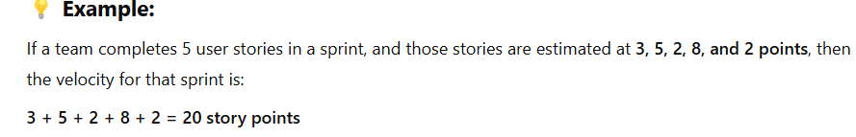
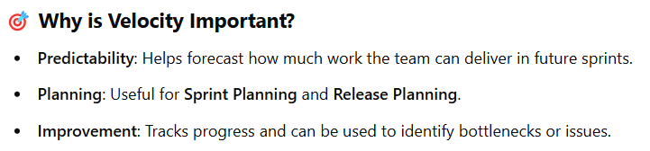

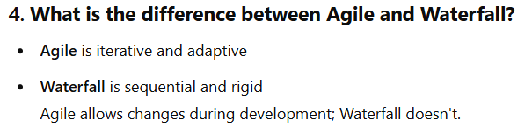

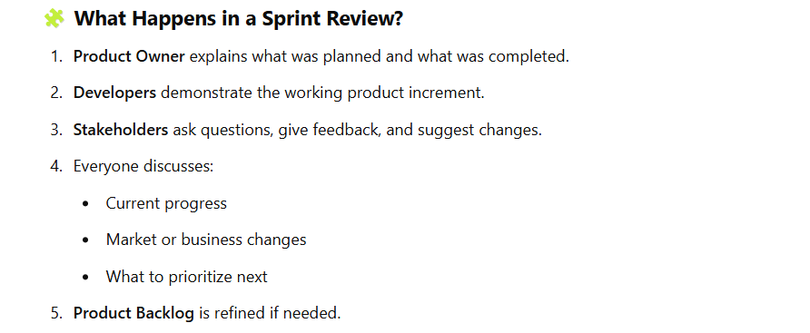
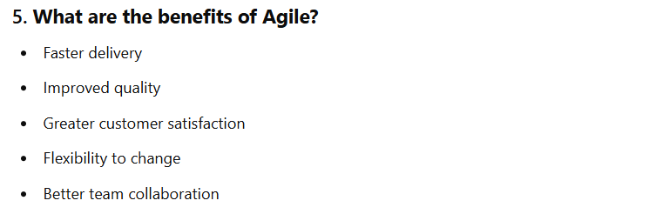

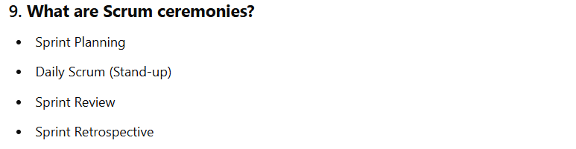

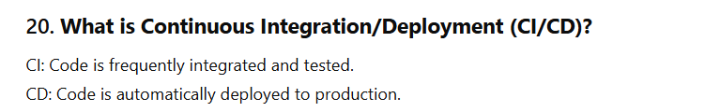

-----------------------------------------Automation Java--------------------------------------

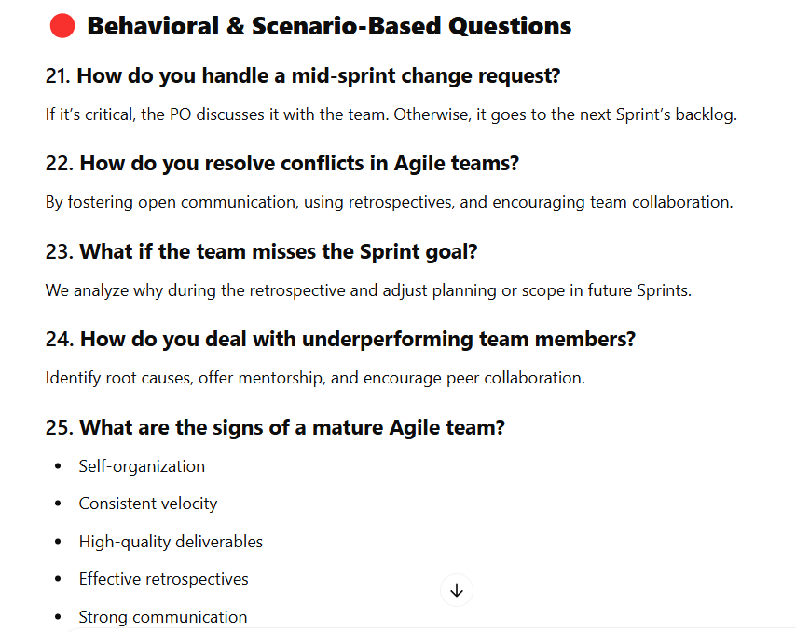

Que – What is java ?
Ans – Java is a programming language
# download and inatall java – done
# download eclipse – done
# cmd to check the java version – java -version - done

#steps to create the java project in eclipse ide
Create a java project
Create a Java Package
Create Java classs
JDK - Java development
JRE - Java Runtime Environment
JVM - Java Virtual Machine

Note -
1. in single java project we can hava multiple java packages
2. empty java package will be in white color and non empty java package will be in brown color
3.in single java package we can hava multiple java classes
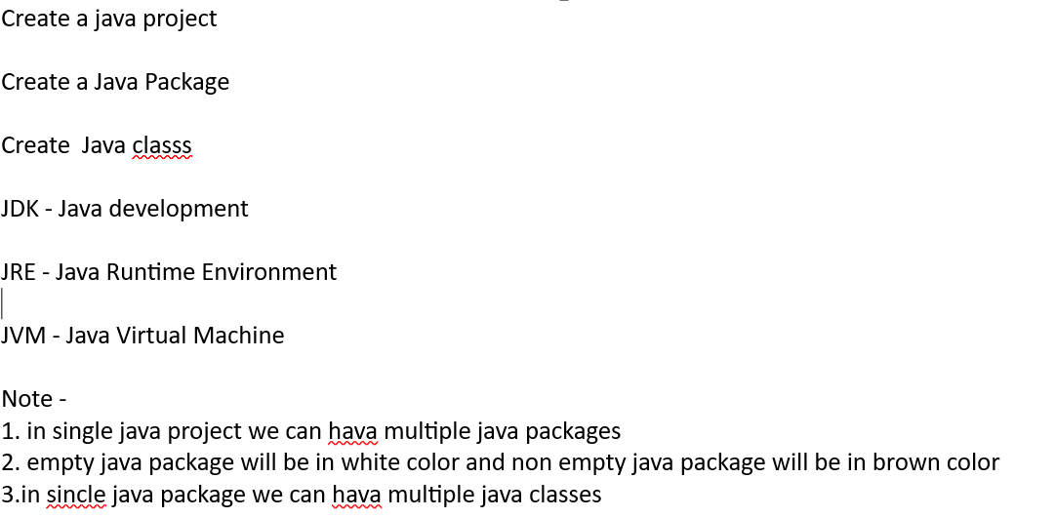
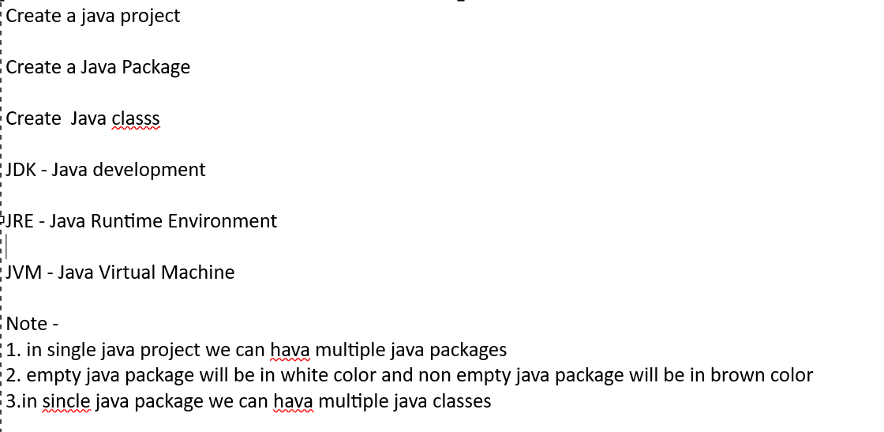

Jre System Library
# Jre system library is a collection of jar files
# Jar file is a collection of java packages
# Java packages is a collection of java classes

# steps to create java project , java package and java class
Java Project
File <new <others <java Project < Project Name<Finish
Java Package
Click On java Project <New<Java Package<Package Name <Finish
Java Class
Click on package name < New<Class Name <finish

We can do any thing together Java & Eclipse
# Java version 17 is the stable version
# Download Eclipse
# Selenium – selenium 4 version stable version

Steps to install the java
#open google and type java 17 download and install
# Go to C:\Program Files\Java in this location look for the folder called java if this folder is present that means java is successfully installed in your machine
#Open cmd and type Java -Version and hit enter button installed java version should display

Steps to install Eclipse
#open google and type download eclipse

Ques – Java Features ?
Ans - # Object Oriented
# Platform independent

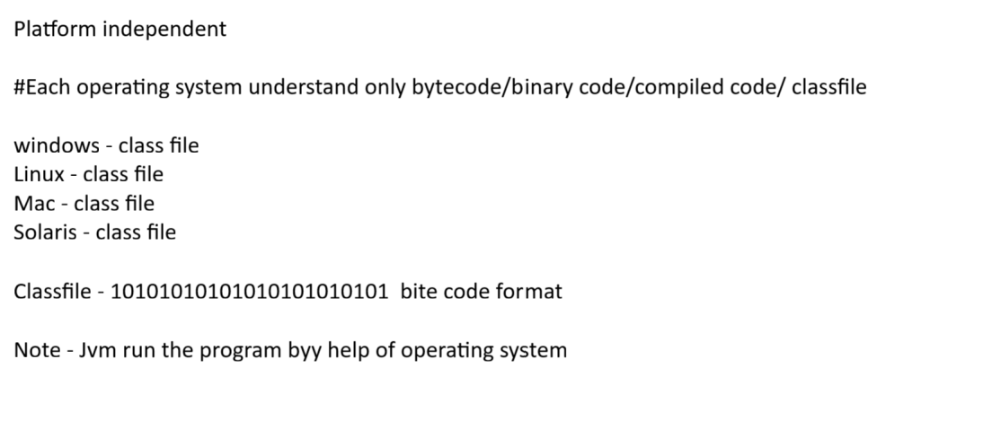

Que – What is object in java ?
Ans – Object is the super class in java
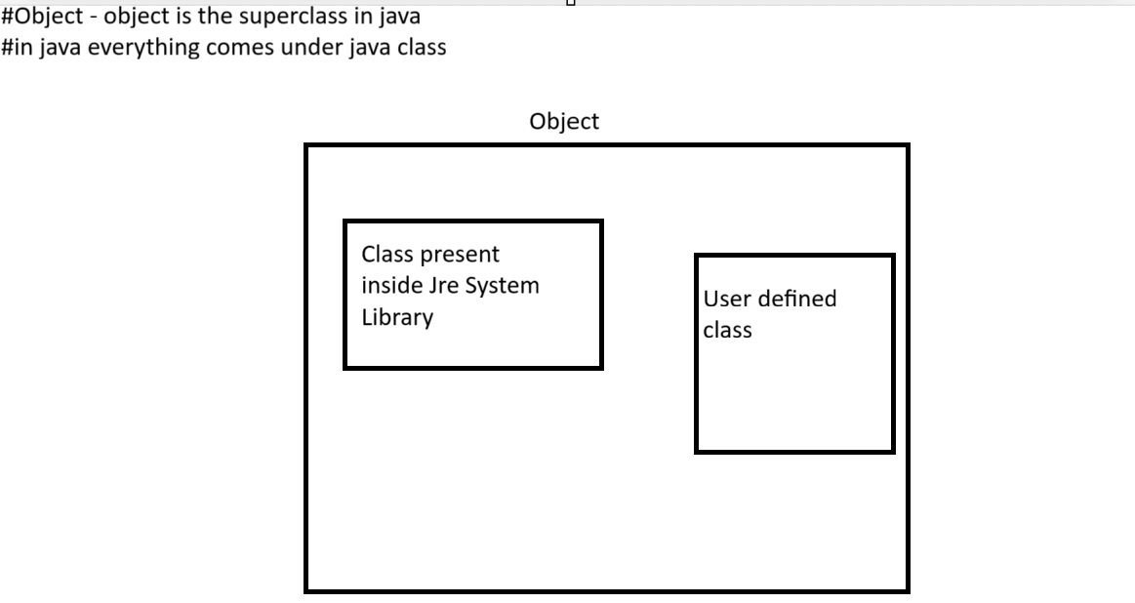

Que – Object creation statement syntax
Ans – Syntaz
className referenceName = new className();

Que- What are the access modifiers ?
Ans – it is used to define the visibility scope of class/methods/constructor/and variables
  - Private – access level will be with the same class only
  - Public – when we want to access the code from anywhere(all class in package)
  - Default – access level will be with in the same package
  - Protected – access level will be with in the same package and child class (even if in the different package)

Que – what is method in java ?
Ans – Java method() will always be responsible to perform an operation

Que – Premitive and Non Premitive variable in java ?
And – Premitive – byte, char, short, int, long, float, double,Boolean
Non-Premitive – string, array, class, num

Note – in java each predefined classes are known as non primitive datatype

#java implementation to archive platform independency
Source code > java compiler > classfile
Que -Java file extensions
Ans -
  - Source File = (.java file)
  - Class File = (.class file)

Package – Package is nothing but it is a Java Keyword and whatever is showing in purple color in eclipse like package, public class, Public static void these all are called keywords.
Ex-
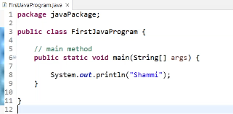
Java Package – Java Package is a package name in java
EX- package javaPackage;
Semicolon(;) – Semicolon is a completion of statement (;)
Public – Public is java keyword & access modifiers.
Class – Class is a java keyword and also it is blueprint, class will be created inside the java package.
Ex-
Class Name – FirstJavaProgram
Opening/Closing Paranthesis {} – Body of class/methods.
Void – Keyword as well as returntype
Main() – Method name –Main method is required because program execution is start from the main method only.
String -- String is a class name
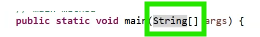
Shortcut to write main method – write ma under class body, and then press CTRL+SPACE and then select main().

Shortcut key to print statement – Write syso and then press CTRL+SPACE and

Note – if * is showing in the top of the program that means your program is not saved and to save the java program use CTRL+S
Note – if the main method will not present in java class that class will not execute that means java main method is mandatory for program execution.
What is System – System is a class and System should always in upper case.
Ex.

Note – Any thing in java in double quotes ("Gajendra") by default it is called string parameter.

Note – 1. In a single Java project, we can create n no of Java Packages.
2. In a single Java package, we can create n no of java classes.
What is JRE System Library – The JRE System Library is a collection of jar files and the jar file is a collection of java packages.
What is java Package – Java package is a collection of java classes.
Que – What is Source Code in java ?
Ans -- Source code is the human-readable code written in a programming language (Java, in this case). It's saved in a .java file and contains classes and methods.
Ex (Hello.java)

Que – What is Byte Code in java ?
Ans -- Bytecode is the compiled version of source code. It's not readable like source code and is meant to be executed by the Java Virtual Machine (JVM). Bytecode is stored in .class files.
When you compile Hello.java, it becomes Hello.class.
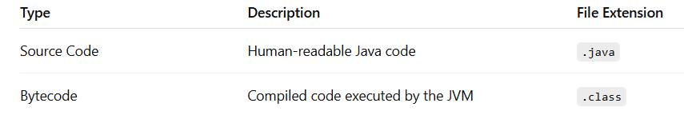
Que – What is JVM ?
Ans – JVM run the program with the help of operating system. whenever we run the java program always classfile get executed. It Actually run the program (Class File).

Que - What is a Class File in Java?
Ans - A class file in Java is a file with a .class extension that contains bytecode — the compiled version of your Java source code. It is generated automatically when you compile a .java file using the Java compiler (javac).

Que – What is java and what are the java features ?
Ans – Java is a high level class based object oriented programming language I was developed by the Sun Microsystems.
Feature OF Java :-
  - Object Oriented – in this the javac compiler is used to convert Source code into Bytecode
  - Platform-Independent -- Java source Code is compiled by the javac compiler and convert into the byte code. This byte code is a platform independenet code because it can be run on multiple platform (OS)
Java programs are compiled into bytecode, which runs on the Java Virtual Machine (JVM). This means you can write a program once and run it anywhere ("Write Once, Run Anywhere" - WORA)

3.Secured –

Que – Write the program in java ??
Ans --
package JavaPackage;

public class FirstJavaProgram {

public static void main(String[] args) {
// TODO Auto-generated method stub
System.out.println("Gajendra");
System.out.println("Brijendra");
System.out.println("Dhirendr");
System.out.println("Birendra");
aMethod();
bMethod();

int a =7;
System.out.println(a);
}
public static void aMethod() {
System.out.println("Hello a method");
}
public static void bMethod() {
System.out.println("Hello b method");
}
}

OUT PUT –
Gajendra
Brijendra
Dhirendr
Birendra
Hello a method
Hello b method
7

Same program screen shot is mentioned below
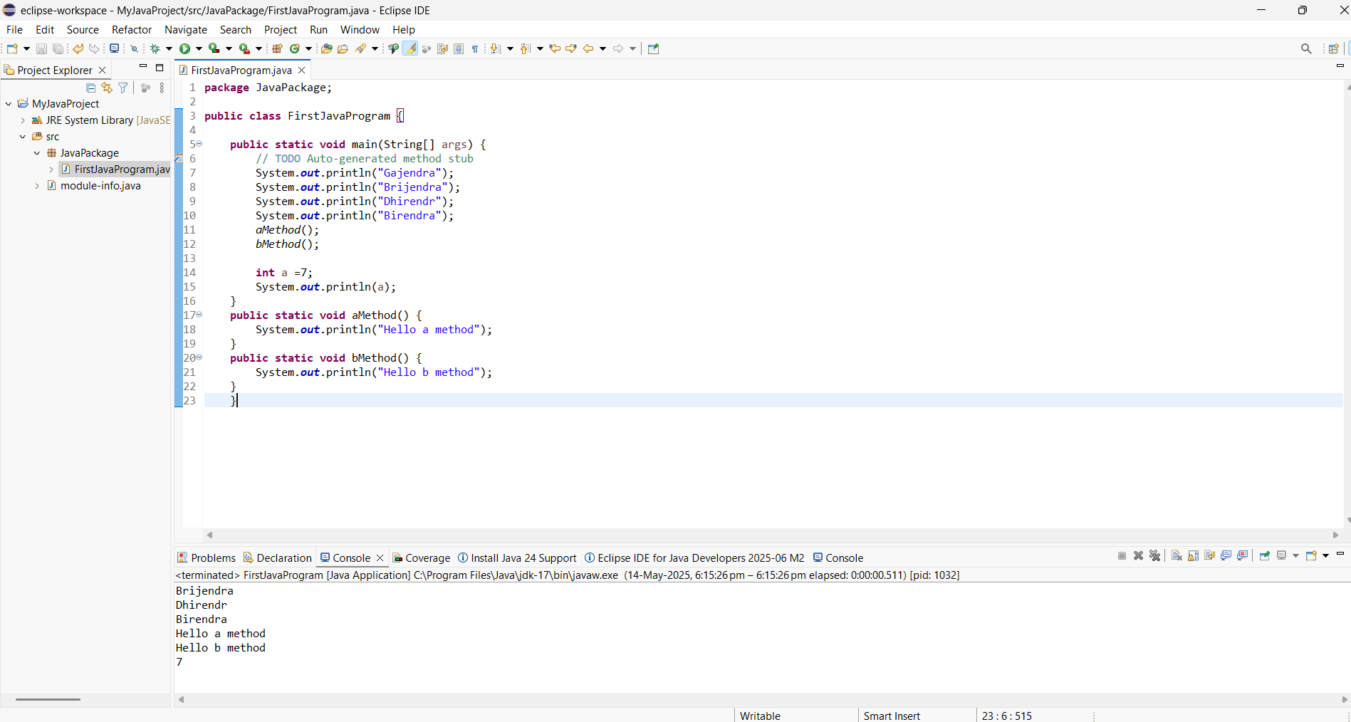

Que – What is JVM Architecure?
Ans --Loads .class files (compiled Java files) into the JVM.
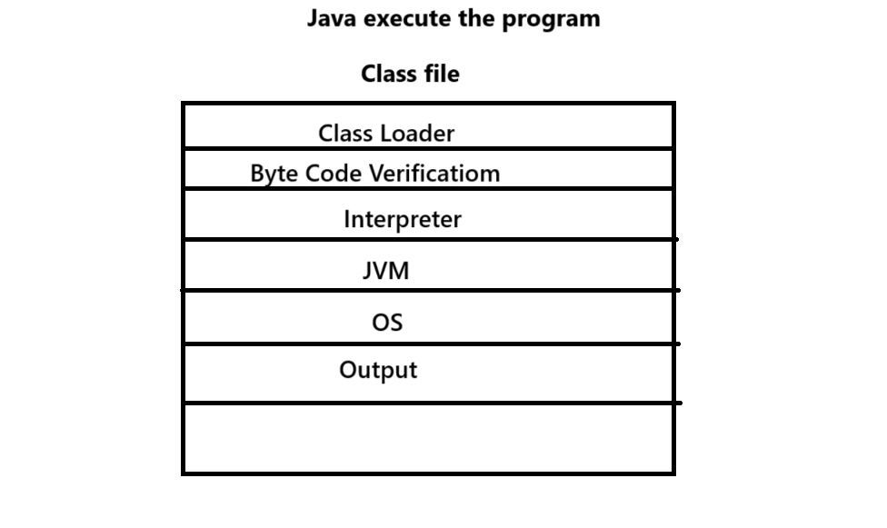
Que – What is Data Type In Java?
Ans – In Java, a data type specifies the kind of data a variable can store, such as numbers, characters, or objects.
There are two types of DataTypes
Primitive Data Type –
- Byte – 1 byte (8bits) -0
- Char – 2 bytes (16bits) –u\0000
- Float -- 4 bytes (32 bits) -0.0
- Short – 2 bytes (16bits) -0
- Int -- 4 bytes (32 bits) -0
- Long – 8 bytes (64 bits) -0
- Double – 8 bytes (64 bits) -0.0
- Boolean – Less the 1 byte (1 bits) (True/False) –
Ex – Program to verify the default value
package JavaPackage;

public class Test {
float f;
public void a() {
System.out.println(f);
}
public static void main(String[] args) {
Test t = new Test();
System.out.println(t.f);
}
}

OUT PUT -- 0.0

If id change the value of float f = 6f then what is the output of the program

package JavaPackage;

public class Test {
float f = 6f;
public void a() {
System.out.println(f);
}
public static void main(String[] args) {
Test t = new Test();
System.out.println(t.f);
}
}

OUT PUT -- 6.0

Non Primitive DataType –
String , Array, Interfaces. Enums

Que – What is Ram ?
Ans – Random Access Memory.
1 GB Ram – 1073741824 bytes
package JavaPackage;

public class Test{
float f;

public static void main(String[] args) {

Test t = new Test();
System.out.println(t.f);
}

Out Put –0.0

Que – What is Object in java ?
Ans – Object is a super class in java. everything is in java is an object and each and every class comes under object so that the reason java is an object oriented programming language.

Que – What is variable in java ?
Ans -- it is a named memory location used to stored variable values.

Ans – There are three types of variables in java.
- Local Variable – Local variable defines inside the method body
EX -package JavaPackage;

public class FirstJavaProgram {

public static void main(String[] args) { // This is the main method Means(Method Body)

System.out.println("Gajendra");
System.out.println("Brijendra");
System.out.println("Dhirendr");
System.out.println("Birendra");
aGajendra(); // User defined methods
bGajendra(); // User defined methods

int a =7; // Local Variable
System.out.println(a);
}
public static void aGajendra() {
System.out.println("Hello a method");
}
public static void bGajendra() {
System.out.println("Hello b method");
}
}

- Global Variable – Global variable defines inside the class body but outside the method body
EX -package JavaPackage;

public class FirstJavaProgram {

int b = 7; // Global variable
int c = 9; // Global variable

public static void main(String[] args) { // This is the main method
System.out.println("Gajendra");
System.out.println("Brijendra");
System.out.println("Dhirendr");
System.out.println("Birendra");
aGajendra();
bGajendra();

int a =7; // Local Variable
System.out.println(a);
}
public static void aGajendra() {
System.out.println("Hello a method");
}
public static void bGajendra() {
System.out.println("Hello b method");
}
}

- Static Variable – static variable defines inside the class body but outside the method body along with static keyword.
EX - package JavaPackage;

public class FirstJavaProgram {

int b = 7; // Global variable
int c = 9; // Global variable

static int g = 5; //static Variable (in static variable varible should be in italic g is italic
static int d = 9; //static Variable (in static variable varible should be in italic d is italic

public static void main(String[] args) {
System.out.println("Gajendra");
System.out.println("Brijendra");
System.out.println("Dhirendr");
System.out.println("Birendra");
aGajendra();
bGajendra();

int a =7; // Local Variable
System.out.println(a);
}
public static void aGajendra() {
System.out.println("Hello a method");
}
public static void bGajendra() {
System.out.println("Hello b method");
}
}

- Variable Syntax –
EX – Datatype Variable name = Variable value;
Ex – Int a = 5;

EX -Program of Local Variable -:

package JavaPackage;

public class Variable1 {

public static void main(String[] args) {

int a = 5; // int type local variable
System.out.println(a); // it will print 5

int x = 100; // int type local variable
System.out.println(x); // out put will be 100

x =200; // in
System.out.println(x); // 200

x = 400;
System.out.println(x); // 400

char c = 'a'; // char type variable should be placed inside the single quote
System.out.println(c); // a

boolean b = true;
System.out.println(b); // true

b = false;
System.out.println(b); //false

System.out.println(3>20); // false

int e = 100; // int type local variable
int f = 200; // int type local variable

boolean z = e < f;
System.out.println(z); //true

OUT PUT –
5
100
200
400
a
true
false
false
true

Que – Non Primitive Data type-
Ans -- String , Array , Enum, interface these are the non primitive data type
String :- * string is a pre-defined class in java as well as it is a non primitive data type
* it is basically a sequence of characters
* It should be given in the double quotes ex = “Gajendra yadav”
* Space given inside the double quotes are also consider as a part of string
Ex- public static void main(String[] args) {
Ex – How to find the length of string
package JavaPackage;

public class Variable2 {

public static void main(String[] args) {

String a = "Gajendra Yadav"; // string type local variable
// if i want to print the length of string parameter
System.out.println(a.length());
System.out.println("Length of the string : " + a.length());

}

}

OUT PUT –

14
Length of the string : 14

Que – What is package?
Ans – Package is a java folder used to group java class, interfaces, Enums.
class, interfaces, Enums –all these 3 are java files.

Que – What is methods in java ?
Ans – it is a sub class of a java class used to implement a logic to perform any operations.

Que – Java is platform dependent / independent ??
Ans – Java Software – Platform dependent
Java Programming Langage – Platform Independent

Que – What are the steps to execute the java program in eclipse ide?
Ans 1. Create a java project
2. After than create the Java Package
3. After than create the java class name
4. Execute the class and got the output

Oue – Java Basic Programmig Elements.
Ans –
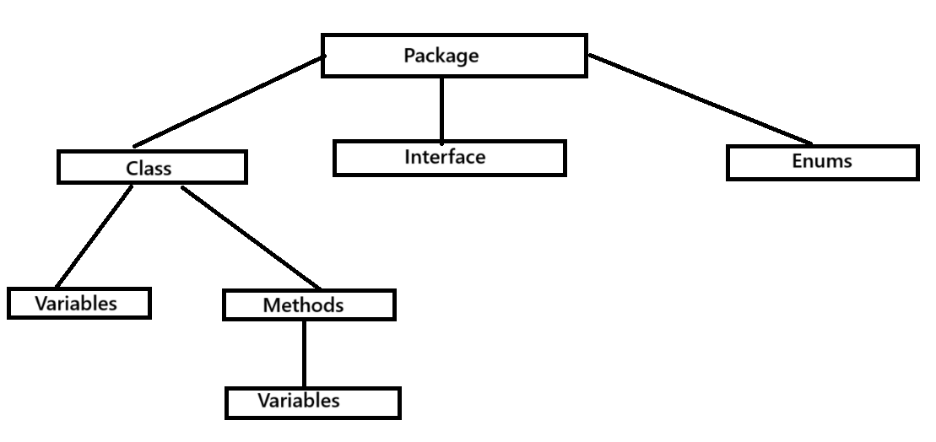

Que – What is void in java ?
Ans – Void is a java keyword as well as return type.

Note - in java each class are known as non-primitive data type.

Que – If we print the default value of float how to write a program for the same ?
Ans - package JavaPackage;

public class Variable3 {

float a;
public static void main(String[] args) {

//String s = "Hello Java program";
//System.out.println("Total length of string: " + s.length());

Variable3 b = new Variable3();
System.out.println(b.a);
}
}

Out will be the default value of float -0.0
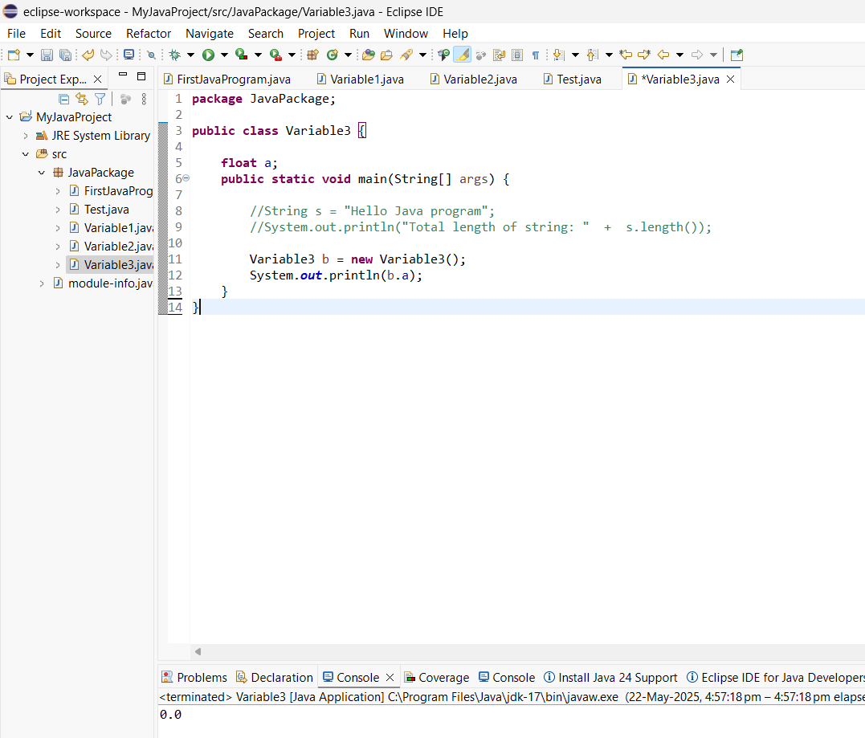

When we take the float F capital or upper caseslike F than what will be the output

package JavaPackage;

public class Variable3 {

Float a;
public static void main(String[] args) {

//String s = "Hello Java program";
//System.out.println("Total length of string: " + s.length());

Variable3 b = new Variable3();
System.out.println(b.a);
}
}

Out put will be the - Null

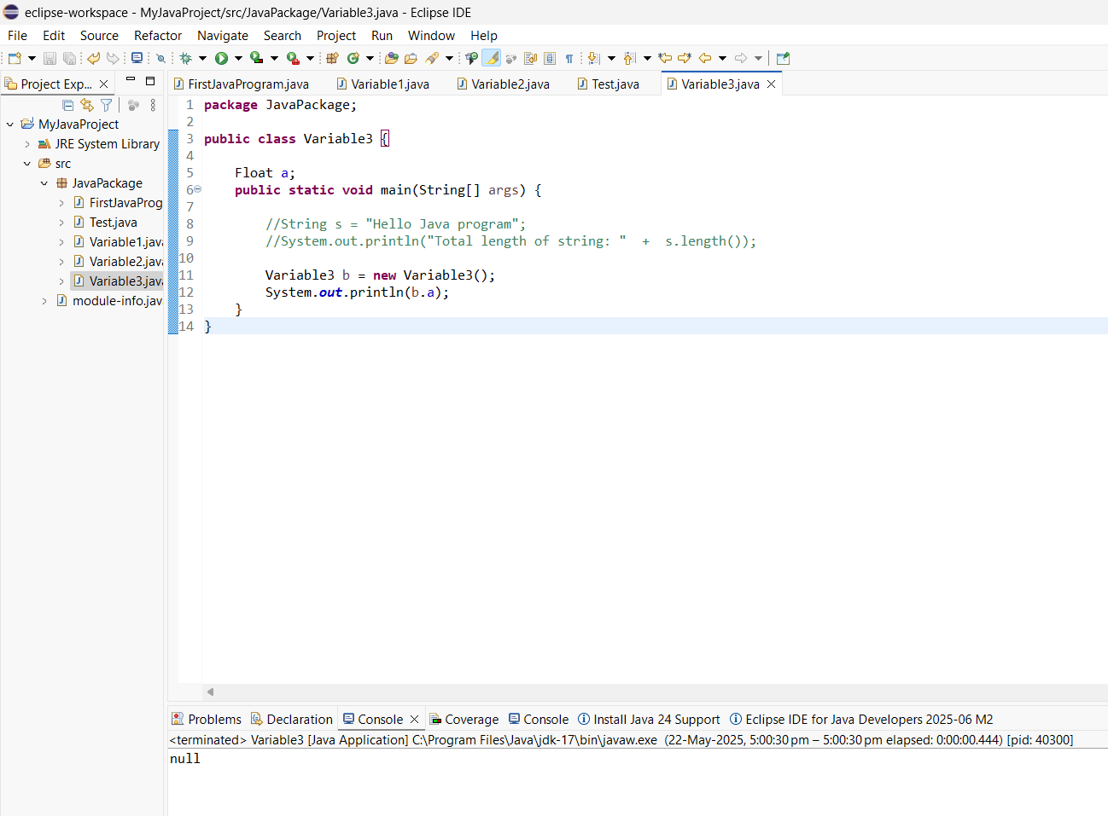

Que – What is Platform Dependent and Platform Independent in java ?
Ans # - Platform Dependent – Any software that is compiled with one operating system if it is not run in different operating system then the application is called platform independent and the programming language that is used to developed this software is know as platform dependent programming language ex –c c++
# Platform Dependent -- Any software that is compiled with one operating system if it is run in different operating system then the application is called platform independent and the programming language that is used to developed this software is know as platform dependent programming language ex –Java

Que – What is the different between print() and println() method ??
Ans – Print() - it is used to print the output in a same line
Println() - ln ,means line next so this println() method is used to print the optput in next line

Que – Naming convention of basic programming language ??
Ans -- # package – package name should start with lower case. It is recommended not mandatory .
# Class/Interface/ Enum – name should start with upper case. It is recommended not mandatory
# Varisble – name should start with lower case. It is recommended not mandatory .
# Methods -- name should start with lower case. It is recommended not mandatory .

Que – What is Java Comments ??
Ans – A description about the basic programming element is known as java comments it is used to understand the purpose of code.
# Single line comment -- //
# Multiline comment -- /* line of code*/

Que – What is Java Identifiers ??
Ans – It is a name of basic programming language.
Identifiers should only contains Alphabets (A to Z) Digits ( 0 to 9) special character ( _ and &).
Identifier should not start with a digit . a digit can be used 2nd character onwards like Ex - R2
Identifiers should not contains space in the middle of the word.
Identifiers is a case sensitive that means (a ! =A)
Examples like – public void amethod () ; -valid
Public void a#method(); -invalid
Public void a_method() ; - valid
Public void a$method() ; - valid
public void a8method () ; -valid
public void 8nmethod () ; -invalid

Que – What is java keywords ??
Ans -- # java keyword are predefined identifiers that means we cannot change the name of java keyword and java keyword exist inside the javac compiler.
# anything in eclips in purple colour is known as java keywords.
# each character in java keyword will be in lower case only.
# java keyword has the special meaning inside the java source code.
# basicall the java keyword is used to communicate with the java c compiler and jvm about the operations we are about to perform the java program.
In Java we have 51 Keywords as below.
- Java files – Class, Enum, Interface (3)
- Datatype – byte, int, char,float,long,Boolean,short,double ( 8)
- Return type – void (1)
- Memory Location – static , new (2)
- Conditional Statement – if, else,switch,case,default(5)
- Loop –while, do , for(3)
- Transfer – break, continue, return(3)
- Modifiers – static, final,abstact,native,transient,volatile,sychronysed,strictft (8)
- Inheritance – extend, implements(2)
- Exception Handling – try,catch,final,throw (4)
- Unused keyword – const, goto (2)
- Validation – assert (1)
Total Keyword – 51

Que – What is datatype Hierarchy ??
Ans –
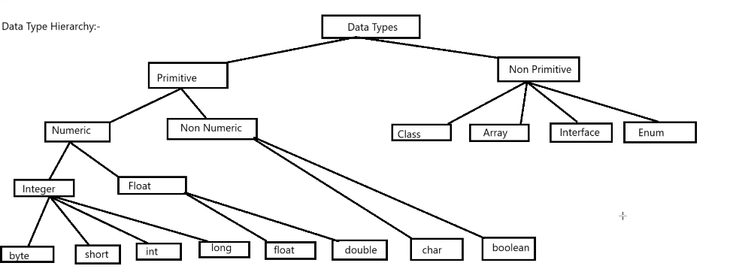

Que - Program to reverse the name ?
Ans -
G A J E N D R A
A R D N E J A G

package JavaPackage
public class Reverse {
public static void main(String[] arg);
{
String name = 'Gajendra';
string Reversed = '';
for(i=0; i = name.length() - 1; i--) {
reverved + = name.charAt(i);
}
System.out.println("Original" : + name );
System.out.println("reverved" : + reversed);
}
}

Output –
Original: G A J E N D R A
Reversed: A R D N E J A G

Que --What is Selenium Web Driver & Selenium Grid ??
Ans – .Selenium is a free and open-source web application automation tool .
There are four componentsof selenium
- Selenium Rc --Selenium WebDriver is a successor of Selenium RC with enhanced capabilities.
- Selenium Grid --Selenium Grid for distributing test cases and browser support
- Selenium IDE --Selenium IDE is an open-source test automation tool that can record and playback your actions on the web
- Selenium Web Driver --Selenium WebDriver allows running scripts on multiple browsers and operating systems.

Que – What is Selenium web driver Architecture??
Ans –Web Driver architecture It controls the browser from the OS level.The Selenium WebDriver uses JSON to communicate between client libraries and drivers. The JSON requests sent by the client are converted into HTTP requests for the server’s

Que --What are all the locators that support Selenium?
Ans –Locator in selenium are used to identify the web elements on the web page like (click , Type) etc.
Name: Locates by HTML name attribute.
Ex -driver.findElement(By.name("email"))
CSS Selector: Use CSS syntax to locate element
Ex -driver.findElement(By.cssSelector("input[name='email']"))
XPath: Searches elements in the DOM. Reliable but slow (use xpath expression)
Ex -driver.findElement(By.xpath("//input[@id='email']"))
Class name: : Locates by HTML class attributes
Ex - driver.findElement(By.className("btn-login"))
TagName: Uses HTML tags name to locate web elements.
Ex- driver.findElement(By.tagName("a"))
LinkText: Exact match of link text
Ex -driver.findElement(By.linkText("Login"))
Partial Link Text: Partial match of link text
Ex - driver.findElement(By.partialLinkText("Sign"))

Que – What is X-Path??
Ans – Xpath is the address of the element . Xpath is based on the DOM (Document Object Model).
Xpath Stands for Xml Path
It is a query language to locate Nodes in XML Document
It gives complete address of Web Element
Syntax-: //tagname[@attributename='attributevalue']
// → Selects nodes anywhere in the document.
tagname → The HTML tag (like div, input, a, etc.).
@attribute='value' → Attribute-value pair to match.

Que – How to get xpath of web elements ?
Ans – Xpath is the address of the Element
1.Chrome browser – selectorHub
2.Firefox Browser –Firepath , Chropath
And we can write Xpath manually as well.

Que – There are different ways and methods to write the Xpath ?
Ans -- 1.Absolute XPath – Absolute x path Begains from the root of the element to be located and it’s start with the single slash /
EX -/html[1]/body[1]/div[1]/div[3]/form[1]/div[1]/div[1]/div[1]/div[1]/div[2]/textarea[1]
2.Relative Xpath - A Reletive x path begains from the element to be located and not from the root it start with the double slash symbols //
EX – Syntax - : // tagname[@attributr name = ‘attribute value’]
Single Attribute – Xpath using single attribute
EX -//<HTLM TAG>[attribute name = ‘attribute value’]
//* attribute name = ‘attribute value’]

Multiple Attribute – Xpath using multiple attributes
EX -//<HTLM TAG>[@attribute name1 = ‘attribute value1’][@ attribute name2 = ‘attribute value2’]
//* attribute nane1 = ‘attribute value1’][@ attribute nane2 = ‘attribute value2’]

3.And - Xpath using AND expression –
EX -//<HTLM TAG>[attribute name1 = ‘attribute value1’] AND [@ attribute name2 = ‘attribute value2’]

4.Or - - Xpath using OR expression –
EX -//<HTLM TAG>[attribute name1 = ‘attribute value1’] OR [@ attribute name2 = ‘attribute value2’]

5.Contains() - Xpath using Contains() – Contains() methods help in locating the UI Element using partiall text

EX - -//<HTLM TAG>[Contains(@attribute_name , ‘attribute value’)]
//*[Contains(@attribute_name , ‘attribute value’)]

6.Startwith - Xpath using START with method -: Matching elements with common prefixes.

EX - <input type="text" id="user_name" />
<input type="text" id="user_email" />
EX Syntax -//<HTLM TAG>[Starts with(@attribute_name , ‘attribute value’)]
//*[ Starts with (@attribute_name , ‘attribute value’)]

7.Text() - Xpath using TEXT Method :- text() only matches visible text, not attributes.
EX -// [Text() =’Text displayed on webpage’]

8.Last() - Xpath using LAST Method:- It is used to access the last child node
EX - //Tag-name [@attribute-type= ‘attributevalue’ ][last()]
//input[@type=’text’][last()]

- Position() – Xpath using position -: XPath is used to select nodes based on their position (index)

EX- tag-name [@attribute-type=’attributevalue’[Position() =Value]

Ranking Locators Based on Usage
- ID – Most Commonly Used:
  - If an element has a unique id, it should be your first choice because it's fast and reliable.
- XPath – Used for Complex Scenarios:
  - XPath is used when you cannot use id or need to find elements based on complex conditions (e.g., text, attributes, hierarchy, etc.).
  - It's very flexible but can be slower.
- CSS Selector – Used for Speed and Simplicity:
  - If you need flexibility but don’t require the full complexity of XPath, CSS selectors are a good choice.
  - They're generally faster than XPath, especially when used for simpler selections.

In Conclusion:
- ID is the most commonly used locator for finding web elements because it’s the fastest and most reliable when available.
- XPath is preferred for more complex search criteria (e.g., text matching, hierarchy traversal, dynamic elements), but it is generally slower than ID and CSS Selector.
- CSS Selector is a fast and flexible locator that is often used when you need a balance between speed and versatility.
If you’re working with elements that have unique id attributes, ID is the way to go. Otherwise, for flexibility and dynamic elements, XPath or CSS Selector would be your choice depending on the complexity and performance needs.
Would you like me to show you more specific examples or use cases to help you choose the best locator in different scenarios?

PROS OF CSS SELECTOR
- Fast Execution: Generally faster than XPath, especially when working with simple selectors.
- Flexibility: Allows you to select elements by class, id, attributes, and even using parent-child relationships.
- Readable: CSS selectors are usually more compact and easier to maintain than XPath.
•

Que – What is POM(Page Object Model) ?
Ans – Page object model is design pattern popularly used in test automation that’s create in object repository for web ui elements.
- Each web page is application.
- There is a seprate class for each webpage to identify the web elements of that web page and methods which perform operations on those web elements
Que – What is DOM (Document Object Model) ?
Ans –

Que – What is Ad Hoc Testing ??
Ans – Ad hoc testing is a software testing technique performed without any specific test plan or pre-defined set of steps and it is also known as monkey testing and random testing. Ad hoc testing is a unplanned and unstructured approach of testing.

Que – What is Exploratory Testing ??
Ans --

Que – What is FTP (FileTransfer Protocol)?
And --FTP server is a computer or device running software that allows users to transfer files using the File Transfer Protocol (FTP). Popular FTP clients include
FTP (File Transfer Protocol) uses port 21 for the control channel and port 20 for the data channel
EX-FileZilla, WinSCP, and Cyberduck.

Que – What is SFTP (Secure File Transfer Protocall)??
Ans --SFTP is a network protocol that provides secure file access, transfer, and management functionalities over a secure connection
Secured File Transfer Protocol is more Robust And Reliable than the File transfer protocol.
SFTP uses port 22 by default, which is the standard port for SSH.
sftp user@server.example.com (Connects to the SFTP server using the provided username and server address)

REST API

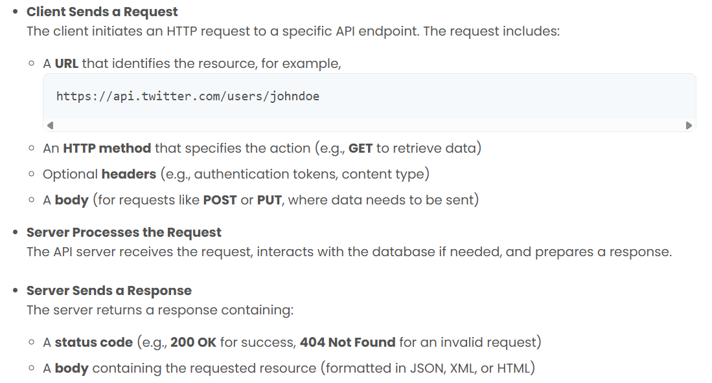

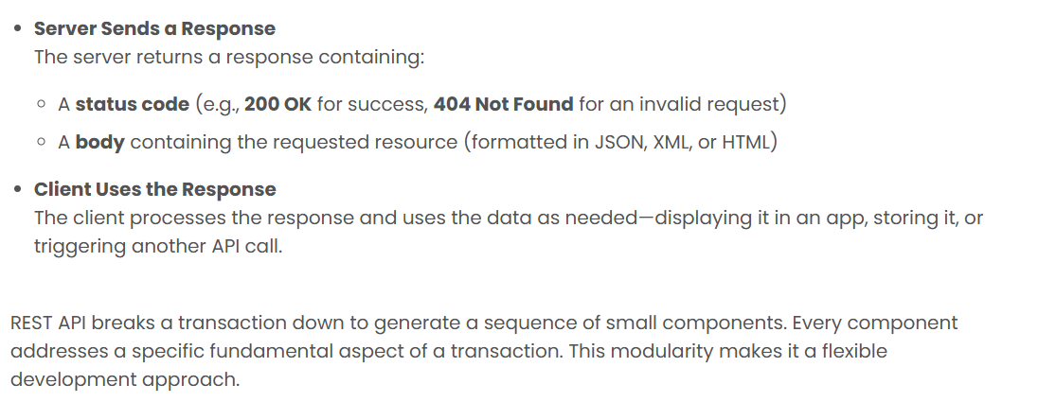

Que -- What is SQL?
Ans – SQL is a (Structure query language) it is s standard programming language used to communicate with relational data base. It allow user to create, read, delete, and update data and provide commands to define database schema and manage the data base security.
Que --What is a database?
Ans --A database is an organized collection of data stored electronically, typically structured in tables with rows and columns. It is managed by a database management system (DBMS), which allows for efficient storage, retrieval, and manipulation of data.

Que -- What are the main types of SQL commands?
Ans – SQL commands are broadly classified into:
DDL (Data Definition Language): CREATE, ALTER, DROP, TRUNCATE.
DML(Data Manipulation Language): SELECT, INSERT, UPDATE, DELETE.
DCL (Data Control Language): GRANT, REVOKE.
TCL (Transaction Control Language): COMMIT, ROLLBACK.

Que -- What is the difference between CHAR and VARCHAR2 data types?
Ans --CHAR: Fixed-length storage. If the defined length is not fully used, it is padded with spaces.
VARCHAR2: Variable-length storage. Only the actual data is stored, saving space when the full length is not needed.

Que --What is a primary key?
Ans --A primary key is a unique identifier for each record in a table. It ensures that no two rows have the same value in the primary key column(s), and it does not allow NULL values.

Que --What is a foreign key?
Ans --A foreign key is a column (or set of columns) in one table that refers to the primary key in another table. It establishes and enforces a relationship between the two tables, ensuring data integrity.

Que --What are the different operators available in SQL?
Ans --Arithmetic Operators: +, -, *, /, %
Comparison Operators: =, !=, <>, >, <, >=, <=
Logical Operators: AND, OR, NOT
Set Operators: UNION, INTERSECT, EXCEPT
Special Operators: BETWEEN, IN, LIKE, IS NULL

Que -- What is a view in SQL?
Ans -- A view is a virtual table created by a SELECT query. It does not store data itself, but presents data from one or more tables in a structured way. Views simplify complex queries, improve readability, and enhance security by restricting access to specific rows or columns.

Que --What are the different types of joins in SQL?
Ans – Joins are used to retrieve the data from one or more tables
Ans --INNER JOIN: Returns rows that have matching values in both tables.
LEFT JOIN (LEFT OUTER JOIN): Returns all rows from the left table, and matching rows from the right table.
RIGHT JOIN (RIGHT OUTER JOIN): Returns all rows from the right table, and matching rows from the left table.
FULL JOIN (FULL OUTER JOIN): Returns all rows when there is a match in either table.
CROSS JOIN: Produces the Cartesian product of two tables.

Que – What is Responsive testing ??
Ans --Responsive testing involves how a website or web application looks and behaves on different devices, screen sizes, and resolutions. The goal of responsive testing is to ensure that the website or web application can be used effectively on various devices, including desktops, laptops, tablets, and smartphones.
Que --What is exploratory testing?
Ans --Exploratory testing is a testing approach that involves simultaneous learning, test design, and execution. It is employed when there is no formalized test plan or script, and when there is a need to discover issues not yet covered by existing test cases.

Exploratory testing is typically performed by experienced testers who use their domain knowledge, intuition, and creativity to identify defects in the software.

Que -- What is Data Integrity ?
Ans --Data integrity is a concept and process that ensures the accuracy, completeness, consistency, and validity of an organization's data.
What's tested:
Data Integrity: Ensuring data is accurate, complete, and consistent.
Data Validity: Verifying that data conforms to expected formats and constraints.
Data Security: Protecting data from unauthorized access and ensuring compliance with regulations.
Performance: Evaluating the database's speed and efficiency.
Schema and Tables: Checking that the database structure is correct and tables are properly defined.
Triggers and Procedures: Testing stored procedures and triggers to ensure they function correctly.

Que – What is Database Testing??
Ans – Database Testing is known as back-end testing or data testing to verify the Accuracy, readability, and performance of the database system to ensure data integrity and consistency.
There are three types of database testing
- Functional testing
- Non-Functional Testing
- Structural Testing

Que --what are the aggregate functions in sql??
Ans --In SQL, aggregate functions perform calculations on a set of values and return a single value, such as totals, averages, or maximum/minimum values. Common aggregate functions include SUM(), AVG(), COUNT(), MAX(), and MIN().
Here's a more detailed explanation:
SUM(): Calculates the sum of values in a column.
AVG(): Calculates the average of values in a column.
COUNT(): Counts the number of rows or values in a column.
MAX(): Returns the maximum value in a column.
MIN(): Returns the minimum value in a column.
APPROX_COUNT_DISTINCT: Returns an approximate count of distinct values in a column, useful for large datasets where speed is prioritized over accuracy.
CHECKSUM_AGG: Calculates a checksum value from multiple rows, often used for data verification.

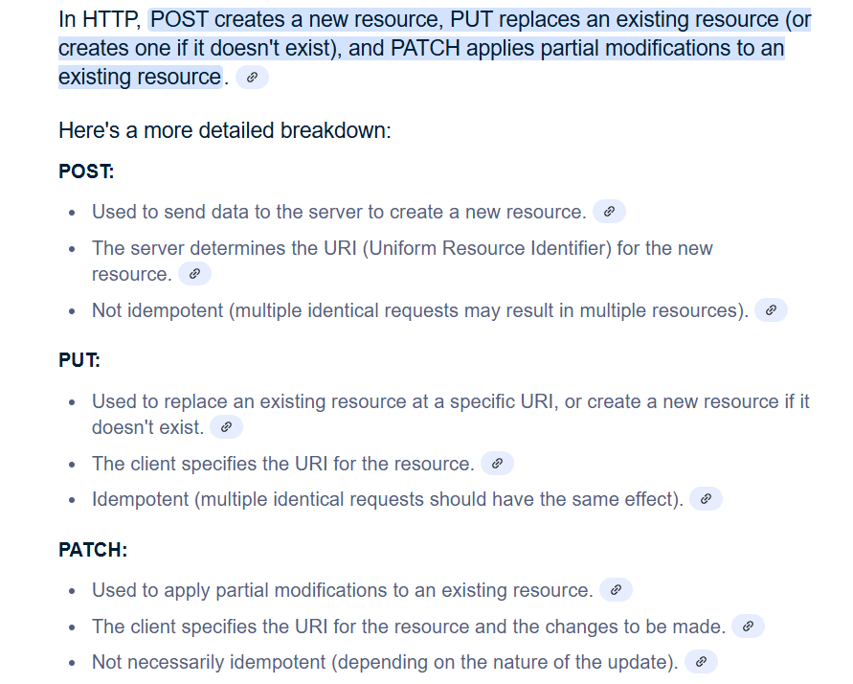

POST is used to send data to a server to create/update a resource
PUT is used to send data to a server to create/update a resource
The PATCH method is used to apply partial modifications to a resource.

Payload in API—The payload of an API is the body of the request, which contains the data to send to the server. We can send the data and receive the data.
Request payload
Response Payload

Que – What is HTTP Request Header??
Ans –When we send something form our client to web server that is known as Request. There are a couple of component
1.URL – Each request must have URL
2.Method –Each Request must have Methods
3.Header –Each request will have header
4.Body –Each request will have Body
5.Data – Each request will have Data

Que – Whatis HTTP Response Header??
Ans – Whatever we get from our web server to the client that is call as Response each response must have a Status code, Response header and Data it contains some compoment.
1.Status Code
2.Response Header
3.Response Data

STATUS CODE– 201 AND 200
201 status code is used when a new resource is created, while a 200 status code is used when the request is successful and data is returned.

400 Bad Request: -- Invalid Request.
403 Forbidden: -- when the server understands your request but refuses to authorize it.
404 Not Found: --Resource not found on server.

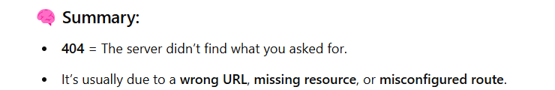

GRAY BOX TESTING - A hybrid approach that combines elements of black box and white box testing, where testers have some knowledge of the internal structure but not complete access.

Que –WHAT IS DEFECT LEAKAGE?
Ans –Defect leakage is a bug that is missed during testing and moves to the next environment. It refers to a bug that is not caught during the testing phase.

QUE –WHAT IS ROLE AND RESPONSIBILITY?
Ans --As a Software Tester, my primary responsibility was to ensure the quality delivery of the product until production deployment.

As a Software Tester, my primary responsibility was to ensure the quality delivery of the product until production deployment, including test case preparation, UAT testing, regression testing, bug reporting and tracking, and coordinating with developers to close reported issues. and upper from this I have shared the test cases with client and showcased the changes on uat after the release deployment on UAT.

In my role, I was responsible for ensuring the quality and functionality of software applications through various testing techniques such as manual testing, regression testing, and automation testing. I worked closely with developers and project managers to identify and resolve defects early in the development cycle

Que- what is the different between Bug & Defects ??
Ans – An error in source code is known as Error
Ans – A bug is an error in the code while defect is occurred due to any deviation raised.

Oue – What is selenium and what are its component ?
Ans – Selenium is an open source tool for automating web browser

Que – What is the different between findElement() And findElements () in selenium??
Ans – 1. findElement():- findElement() method returns the single matching web element using the specific locator if the element is not fund it throws a NoSuchElementException.

FindElement - FindElenent returns the first matching element and it through no such exception if no match is found

Exe-WebElement element = driver.findElement(By.id("username"));

2.findElements() :- findElements() method it return all the matching web elements. Using the specific locator.if no element are found it return an empty list (no exception is thrown)

Findelements - FindElements returns all the matching elements and it returns the empty lift if no matches found

Exe --List<WebElement> elements = driver.findElements(By.className("button"));

Que – What are the types of waits in selenium ?
Ans –

Que – How to handle Alert in selenium??
Ans --To handle alerts in Selenium, you need to switch to the alert box and then take an action (accept, dismiss, etc.).
Exe
Alert alert = driver.switchTo().alert();
alert.accept(); // To click OK on the alert
// OR
alert.dismiss(); // To click Cancel on the alert

Que – What is POM in Selenium??
Ans -- In POM, for each web page in the application, a corresponding Page Object Class is created.
Exe -public class LoginPage {
WebDriver driver;

@FindBy(id = "username")
WebElement usernameField;

@FindBy(id = "password")
WebElement passwordField;
@FindBy(id = "loginButton")
WebElement loginButton;
public LoginPage(WebDriver driver) {
this.driver = driver;
}
public void login(String username, String password) {
usernameField.sendKeys(username);
passwordField.sendKeys(password);
loginButton.click();
}
}

Que --What is the difference between driver.get() and driver.navigate().to() in Selenium?
Ans --driver.get():It is used to open an URL in the browser. It will waits till the page get loaded before moving to the next step.
Exe - driver.get("http://www.google.com");

driver.navigate().to(): -It navigate to an URL as well, it will not wait till the whole page get loaded
Exe -driver.navigate().to("http://example.com");

Que – How do you handle drop-downs in selenium??
Ans --To handle drop-downs, Selenium provides the Select class, which allows interaction with <select> elements.
import org.openqa.selenium.support.ui.Select;
Select dropdown = new Select(driver.findElement(By.id("dropdown")));
dropdown.selectByVisibleText("Option 1"); // Select by visible text
dropdown.selectByIndex(2); // Select by index
dropdown.selectByValue("option1"); // Select by value

Que -- What is the role of driver.quit() and driver.close()?
Ans -- Close () closed the Current Browser whereas Quit () closes all the browsers.
Exe- driver.quit();
Exe- driver.close();

Que – What is Data validation Testing ??
Ans -Data validation testing is the process of ensuring the data stored in the database is correct, complete, and consistent.
With the help of SQL Queries to validate the data’
- Fetch the newly created data.
- Check the Values are stored correctly .
- Compare wih expected values.
Ex- Select * from QC_LOS.QT_LOAN_DETAIL Where Prospect Code = ‘113456

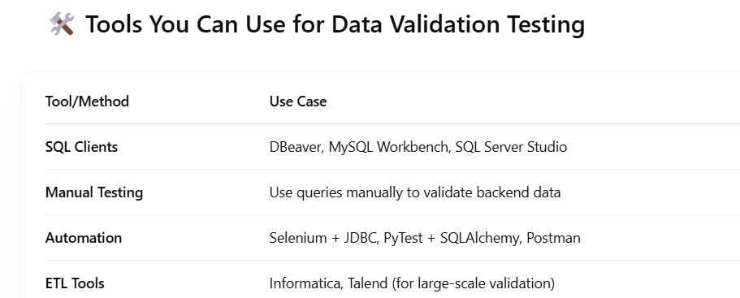

Que - What is Severity?
Ans - The impact of the bug/defect on the application is known as the severity. the severity can be catogerised into three part sand it is decided by the Tester.
Severity is usually decided by the tester or QA team, based on the technical impact of the defect.
1. CRITICAL –In this QA is completely blocked and application cannot be tested at all.
2.MAJOR -A Few functionalities are not working while testing
3.MINOR –Functionalities which do not impact much and can be lived with it for sometime.
4.LOW - It involved minor spelling mistakes and alignment issue involved inside this.

Que – High Severity High Priority Example ?
And –
🔴 7. Blank Screen After Login
• Severity: High – No features are accessible.
• Priority: High – Affects all users immediately.
• Example: After logging in, users see only a white/blank screen.

3. Payment Gateway Not Working
- Severity: High – Users can’t pay.
- Priority: High – Direct impact on business.
- Example: On clicking "Pay Now", nothing happens or shows a server error.

Que – High severity low priority examples ?
Ans –
1. Crash in a Rarely Used Feature
- Severity: High – App crashes.
- Priority: Low – Rarely used feature.
- Example: The app crashes when you open the “About Us” page, which most users don’t visit often.

Crash in a Rarely Used Feature
- Severity: High – web crashes.
- Priority: Low – Rarely used feature.
- Example: While filling the user's middle name, the system shows an "Invalid Input" error, even when the input is correct it a high severity and but low priority

Que – High priority and low severity examples ?
Ans - Incorrect logo and company name displayed on login screen
- High Priority: Branding issue, important before release.
- Low Severity: No impact on login process or app functionality.

Privacy policy link not working on registration page
- High Priority: Legal and compliance issue, must be fixed fast.
- Low Severity: Link issue only, rest of registration works fine
Que – Low severity and low priority ?
Ans –
Alignment issue in user profile edit form on a low-traffic page
- Low Severity: Cosmetic only, no functional problem.
- Low Priority: Page not critical, can wait.

Button color slightly different from the design spec on a secondary page
- Low Severity: Just a cosmetic issue.
- Low Priority: Not visible to most users, no urgent need to fix.

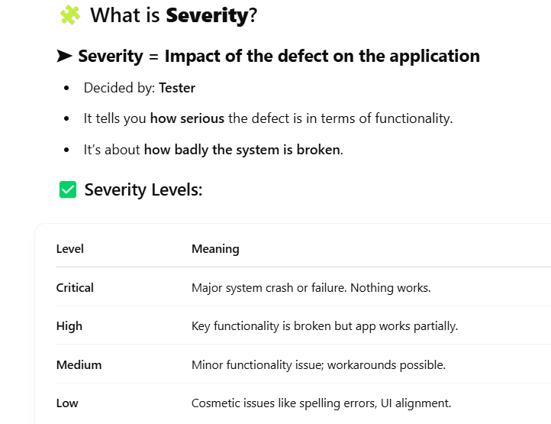

Que – What is Priority ??
Ans – Priority means that how soon the defect should be fixed. And it is decided by the project manager, developer, Product Owner. It tells the urgency to fixed the bug.
Priority is typically decided by the product owner, manager, or dev team, based on business urgency and delivery schedules.
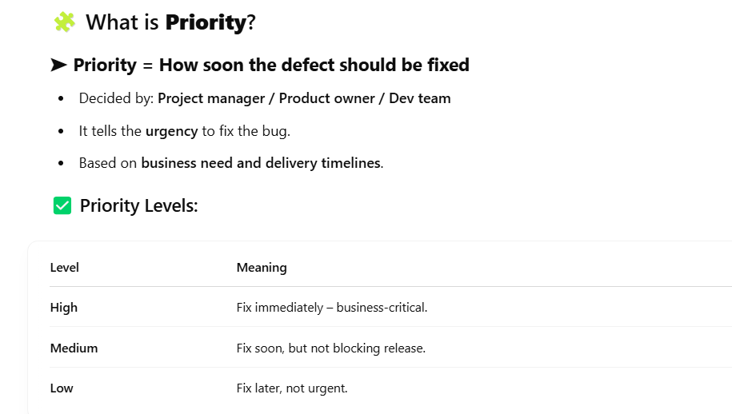

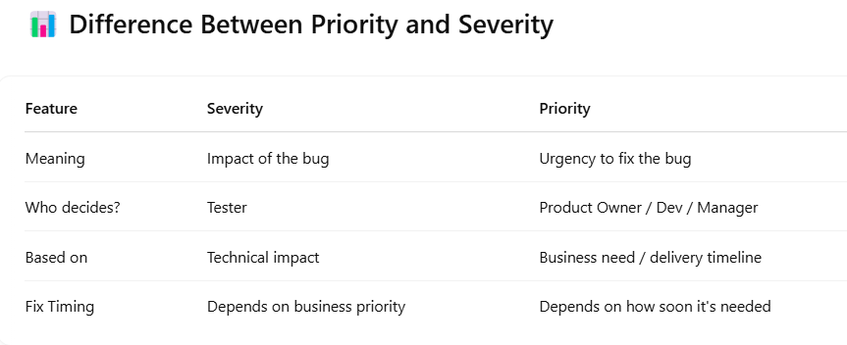

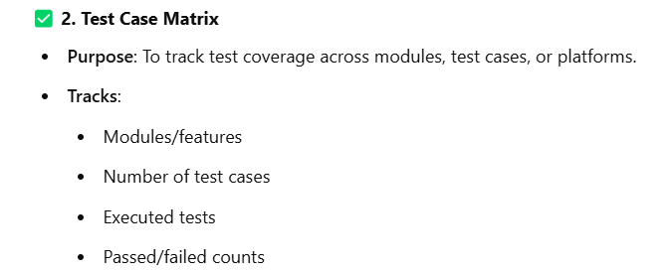
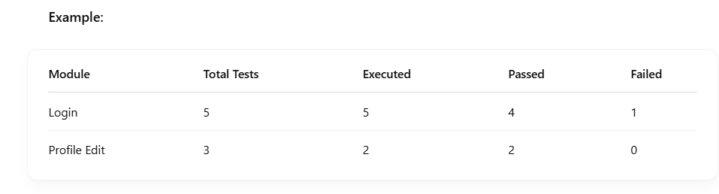

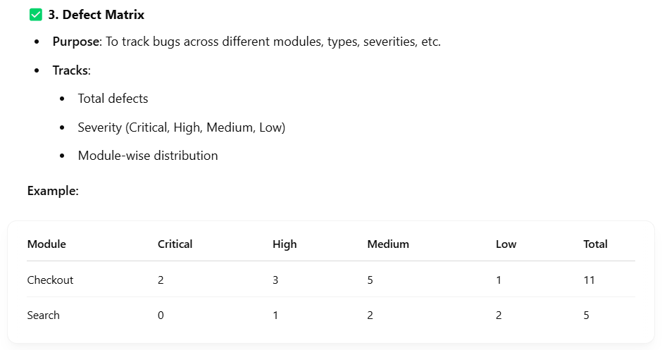

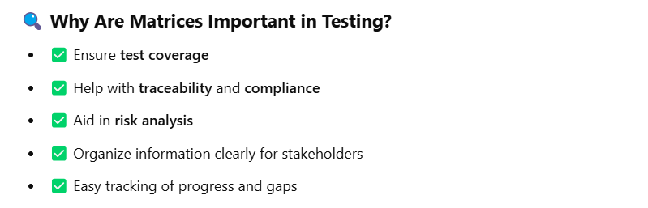

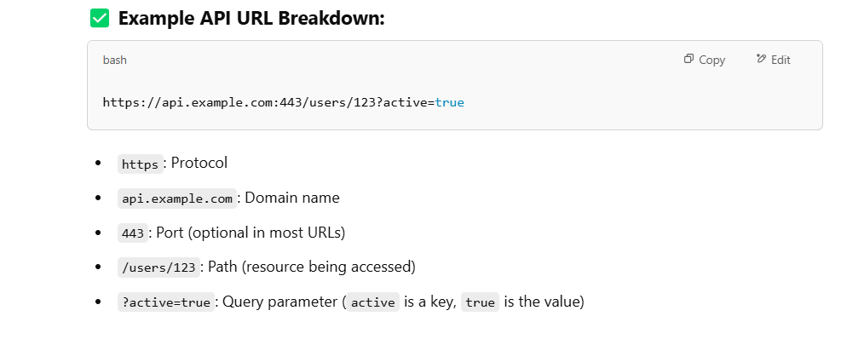

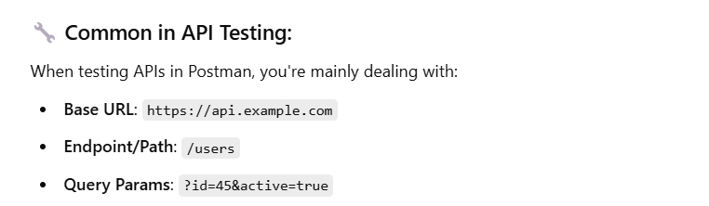

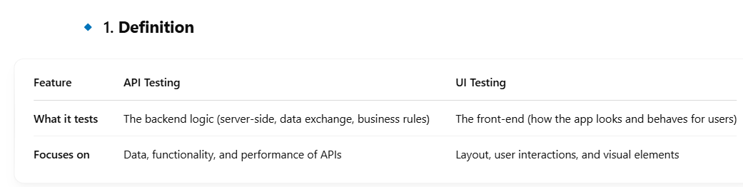

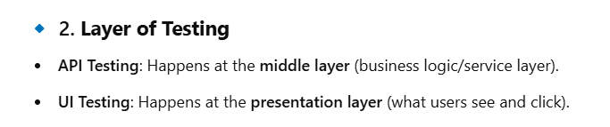

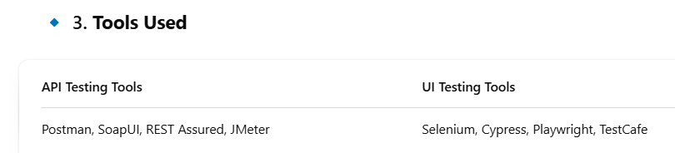

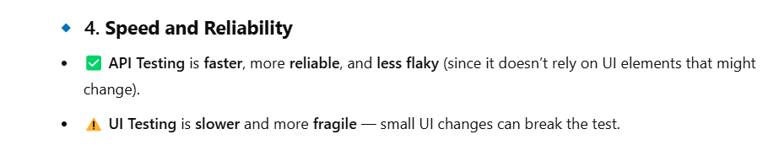
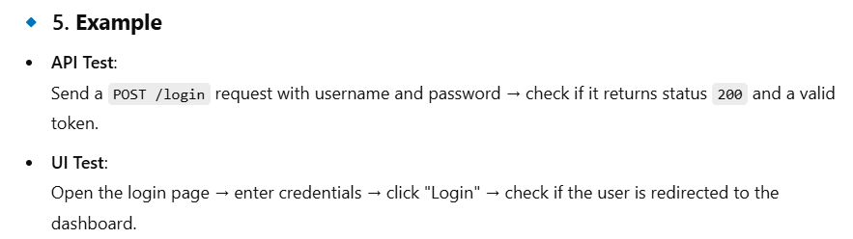
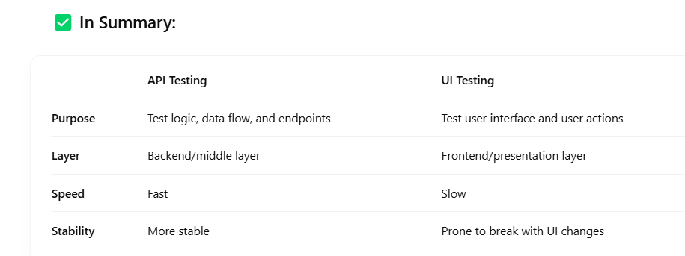

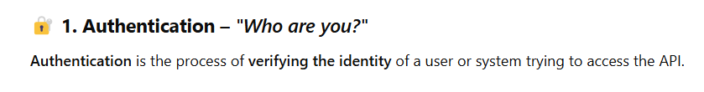
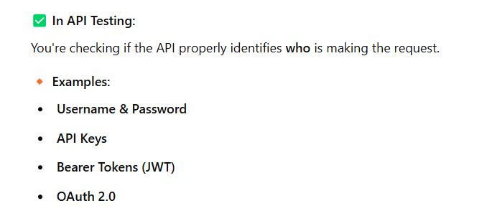

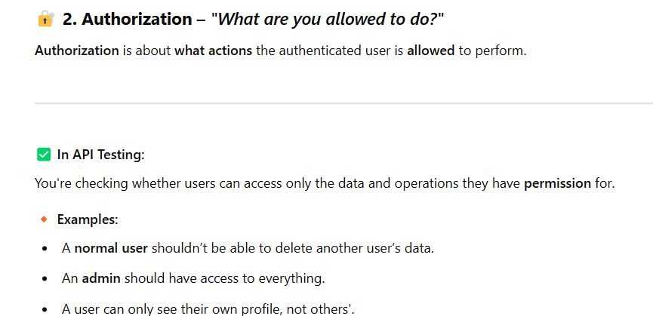

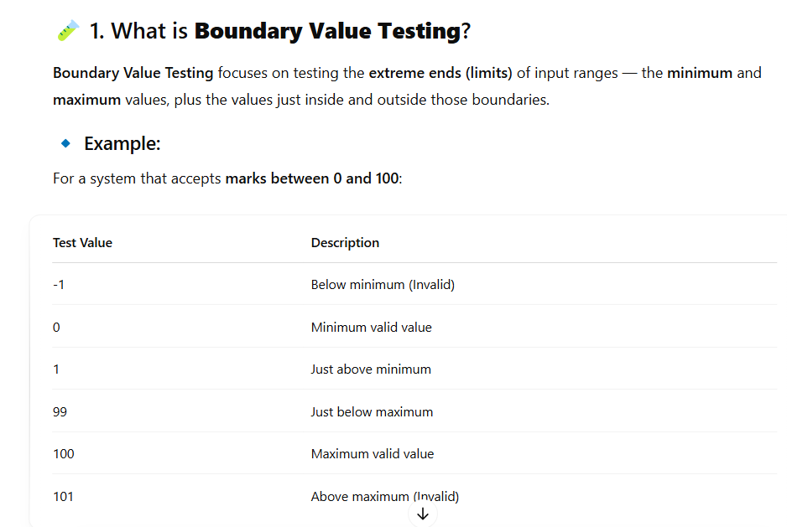

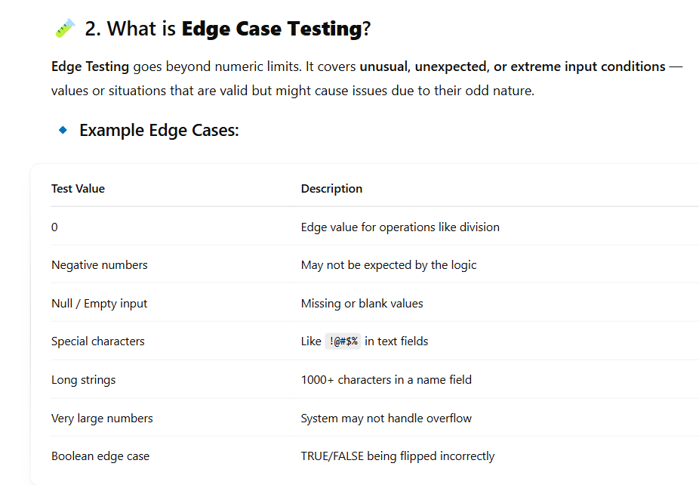

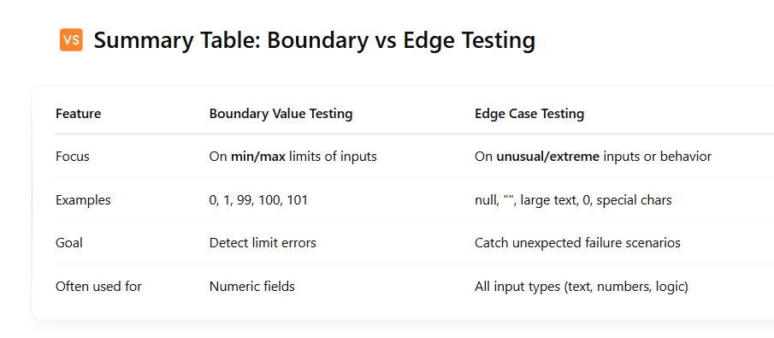

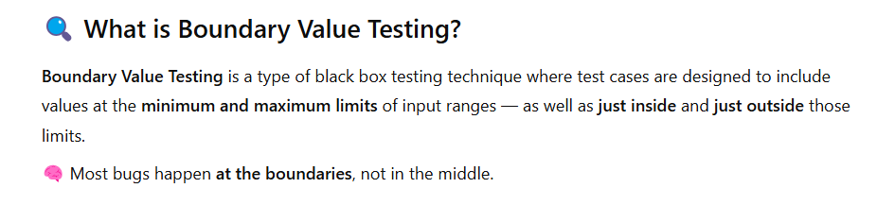

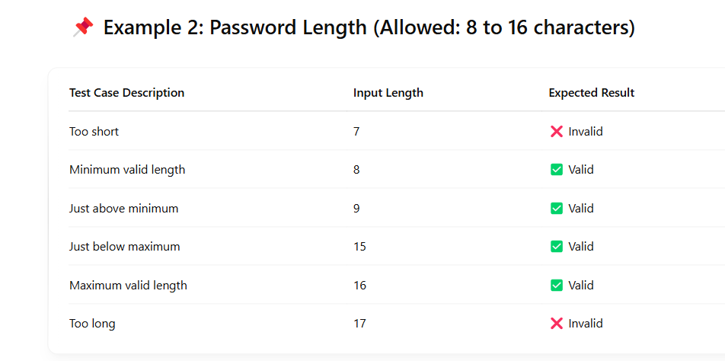

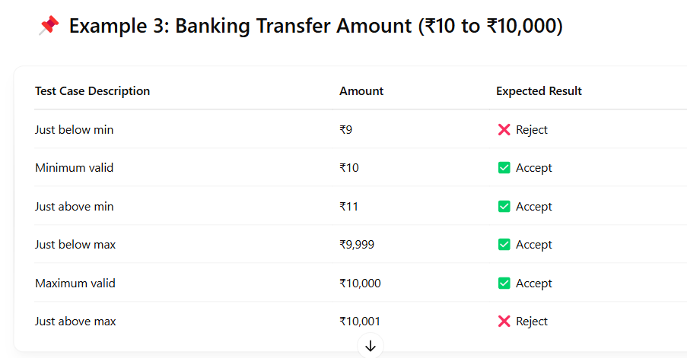

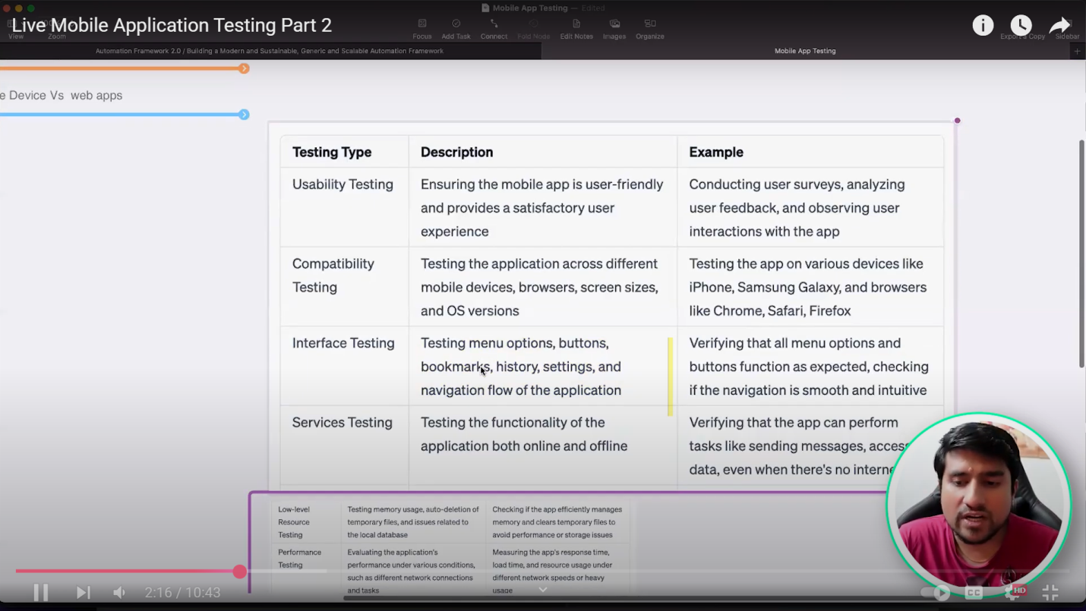

Teat case steps

Test case id
Test case senerios
test case data
Test case pre - condition
test data
actual results
expected result

Que – print the array length
Ans –
package JavaPackage;

public class java1 {

public static void main(String[] args) {

//declaring an array

int a[] = new int [5];

//print the length of an array

System.out.println(a.length);

}

}

Output – 5

Que – Program
Ans

package JavaPackage;

public class Array1 {

public static void main(String[] args) {

// declaring an array
int a[] = new int[5];

//print the length of an array
System.out.println(a.length);

//print the default value of array

for (int i = 0; i < a.length; i++) {
System.out.println(a[i]);
}
// delclring the array values

a[0] = 77;
a[1] = 41;
a[2] = 6;
a[3] = 54;
a[4] = 67;

// a[5] = 99;
Object b[] = {"selenium" , 1 , 2 < 3, 'b' }; {
for (Object c : b) {
System.out.println(c);
}

System.out.println(a[4]);
System.out.println(a[2]);
System.out.println(a[1]);
System.out.println(a[3]);
System.out.println(a[0]);
}

}

}
Out put –

5
0
0
0
0
0
selenium
1
true
b
67
6
41
54
77

Que --- program
Ans ---

package JavaPackage;

public class ObjectArray {

public static void main(String[] args) {

// Defining an object array :- because wecan define any type of array values in the object

Object a[] = {"Gajendra","yadav",1,5,5>8,'r','b',4 };
// print the array with for each loop
for (Object b : a) {
System.out.println(b);
}
}

}
Output –

Gajendra
yadav
1
5
false
r
b
4

Que – Program
Ans –

package JavaPackage;

public class ObjectArray {

public static void main(String[] args) {

// Defining an object array :- because wecan define any type of array values in the object

Object a[] = {"Gajendra","yadav",1,5,5>8,'r','b',4 };
// print the array with for each loop
for (Object b : a) {
System.out.print(b + " ");
}
}

}

Output –-
Gajendra yadav 1 5 false r b 4

Que –-- Program
Ans –
package JavaPackage;

public class ReverseProgram {

public static void main(String[] args) {

// Declaring a string
String name = "G A J E N D R A";
String reversed = "";

// Loop to reverse the string
for (int i = name.length() - 1; i >= 0; i--) {
reversed += name.charAt(i);
}

// Print the reversed string once
System.out.println("reversed string: " + reversed);
}
}

Output –
reversed string: A R D N E J A G

Que – Program to reverse the array string ?
Ans –

package JavaPackage;

public class ReverseTheArrayString {

public static void main(String[] args) {
//Declaring an string

String name[] = {"Gajendra","Surendra","Brijendra","Dhirendr"};

for (int i = name.length - 1; i >= 0; i--) {
System.out.print(name[i]);

System.out.print(" , ");
}
}

}

Output –
Dhirendr , Brijendra , Surendra , Gajendra ,

Que – Even Odd Program ?
Ans –

package JavaPackage;

public class EvenOddProgram {

public static void main(String[] args) {
//Declare a variable to store a interger
int a = 7;
if (a % 2 == 0) {
System.out.println(a + " is even");
}
else
{
System.out.println(a + " is odd");
}
}
}

Output – 7 is odd

package JavaPackage;

public class EvenOddProgram {

public static void main(String[] args) {
//Declare a variable to store a interger
int a = 5;
if (a % 2 == 0) {
System.out.println(a + " is even");
}
else
{
System.out.println(a + " is odd");
}
}
}

Output --5 is odd

Que – even odd program taking input from the user

package JavaPackage;

import java.util.Scanner;

public class EvenOdd {

public static void main(String[] args) {
// Declaring the print statement

Scanner reader = new Scanner(System.in);
System.out.println("Enter the no :");
int num = reader.nextInt();

if (num % 2 == 0)
System.out.println(num + " is even ");
else

System.out.println(num + " is odd ");
}
}

Output --Enter the no :
8
8 is even

Oue – Java array ??
Ans – Java is a collection of similar types of elements that have a continuous memory location.it works based on indexing and the index start with zero/
// defing int type array

Int a[] = new int[5];

- N-1 = Last index value where n is no of last block.
- So last no is = 5-1 = 4
- So 4 wouls be our last index no
Types of an array – Two types of an array
- Single Dimensional Array -
- Multi Dimensional Array –

Program ?

package JavaPackage;

public class Array1 {
public static void main(String[] args) {
// declaring an array

int a[] = new int[5];
//Print the length of an array
System.out.println(a.length);
}

}
Output – 5

Program –

package JavaPackage;
public class Array1 {
public static void main(String[] args) {
// declaring an array
int a[] = new int[5];
//Print the length of an array
System.out.println(a.length);
//Print the default value of an interger values

for(int i = 0; i < a.length; i++)
System.out.println(a[i]);
}
}
Output- 5
0
0
0
0
0

Program –

package JavaPackage;

public class Array1 {
public static void main(String[] args) {
// declaring an array

int a[] = new int[5];
//Print the length of an array
System.out.println(a.length);

//Print the default value of an interger values

for(int i = 0; i < a.length; i++)

System.out.println(a[i]);

//assigning values to array

a[0] = 8;
a[4] = 9;
a[3] = 44;
a[1] = 87;
a[2] = 99;

//Print the array elements
for(int i = 0; i < a.length; i++) {
System.out.println(a[i]);
}
}
}

Output --5
0
0
0
0
0
8
87
99
44
9
Que – we can write the array in below fashion as well ??
Ans – int b[] = {1,2,3,4,5} // defining an isnt array

package JavaPackage;
public class Array2 {
public static void main(String[] args) {
//we can write an array in this fashion as well
int b[] = {1, 2, 3, 4, 5}; // defining an int type array
String s[] = {"Hello","Gajendra"}; // Defing sring type array
Object a[] = {1,2,3,4,'s',3>5,3.6,"yadav"}; // definiing object type array

System.out.println(a.length); // 8
System.out.println(b.length); // 5
System.out.println(s.length); // 2

System.out.println(a[5]); // False
System.out.println(s[1]); // Gajendra
System.out.println(b[2]);
}
}
Output –
8
5
2
false
Gajendra
3
// now modifying an array value using index Program

package JavaPackage;

public class Array2 {

public static void main(String[] args) {

//we can write an array in this fashion as well

int b[] = {1, 2, 3, 4, 5}; // defining an int type array

String s[] = {"Hello","Gajendra"}; // Defing sring type array

Object a[] = {1,2,3,4,'s',3>5,3.6,"yadav"}; // definiing object type array

System.out.println(a.length); // 8
System.out.println(b.length); // 5
System.out.println(s.length); // 2

System.out.println(a[5]); // False
System.out.println(s[1]); // Gajendra
System.out.println(b[2]);

//now modifying an array value using index

a[4] = "sumit";
System.out.println(a[4]);
}
}

Output –

8
5
2
false
Gajendra
3
Sumit

Que Defining multi dimensional array???
Ans – Program

package JavaPackage;
public class Array4 {
public static void main(String[] args) {
// TODO Auto-generated method stub

int a[][] = {{1, 2, 3}, {4, 5, 7}, {7, 9, 5}};
// Total no of rows
System.out.println(a.length);
}
}
Output – 3

package JavaPackage;
public class Array4 {
public static void main(String[] args) {
// TODO Auto-generated method stub

int a[][] = {{1, 2, 3}, {4, 5, 7}, {7, 9, 5}};
// Total no of rows
int row = a.length;
System.out.println(row);
}
}
Output – 3

// Fetch the column

package JavaPackage;
public class Array4 {
public static void main(String[] args) {
// TODO Auto-generated method stub

int a[][] = {{1, 2, 3,7}, {4, 5, 7,7}, {7, 9, 5}};
// Total no of rows
int row = a.length;
System.out.println(row);
// total no of Columns
int col = a[0].length;
System.out.println(col); //
}
}
Output -3 ,4

Program—
package JavaPackage;
public class Array4 {
public static void main(String[] args) {
// TODO Auto-generated method stub
int a[][] = {{1, 2, 3,7}, {4, 5, 7,7}, {7, 9, 5}};
// Total no of rows
int row = a.length;
System.out.println(row);
// total no of Columns
int col = a[0].length;
System.out.println(col); //
}
}
Output –

3
4
1 2 3 7
4 5 7 7
7 9 5

Que -Program to array list how to define the array list and how it execute the object list in run time ??
Ans –
package JavaPackage;

import java.util.ArrayList;
public class ArrayList1 {
public static void main(String[] args) {
//creating array list
ArrayList<Object> obj = new ArrayList<Object>();
// Adding objects in array list it will work as a runtime

obj.add(1);
obj.add(1,"Selenium");
obj.add(3<9);
obj.add(3.7);
obj.add(1);
obj.add('a');
obj.add("tt");

//Print array element first way
System.out.println(obj);
}

}
Output – [1, Selenium, true, 3.7, 1, a, tt]
-----------------------------------------------------------------------
// Print array element using for each loop

package JavaPackage;
import java.util.ArrayList;
public class ArrayList1 {
public static void main(String[] args) {
//creating array list
ArrayList<Object> obj = new ArrayList<Object>();
// Adding objects in array list it will work as a runtime

obj.add(1);
obj.add(1,"Selenium");
obj.add(3<9);
obj.add(3.7);
obj.add(1);
obj.add('a');
obj.add("tt");

//Print array element first way
System.out.println(obj);

// Print array element using for each loop

for(Object b : obj) {
System.out.println(b);

}
}
}
Output --[1, Selenium, true, 3.7, 1, a, tt]
1
Selenium
true
3.7
1
a
tt

Que – what is the OPP’s??
Ans – Opp’s is the Object oriented programming language it involves

1.Inheritance
2.Abstraction
3.Encapsulation
4.Ploymorphysm
1. Inheritance – extends keywords
Class a -Child class
Class b – Parent class
Extend a extend b
Inheritance1

package JavaPackage;

public class Inheritance1 {

int roll = 5; // Global variable

public static void main(String[] args) {
// TODO Auto-generated method stub

}

}

Inheritance2
package JavaPackage;

public class Inheritence2 extends Inheritance1{

int b = 10; // Global variable

public static void main(String[] args) {

Inheritence2 i2 = new Inheritence2();

System.out.println(i2.b); //10
System.out.println(i2.roll);
}
}

OutPut –
10
5

Types of Inheritance
- Single leve inheritance
- Multile level inheritance
1.Single level = A-B (B will inheritance the property of A)
2.Multi level = A-B-C (B will inheritance the property of A ans C will inheritance the property of B)

- Multi Level inheritance
Program
Inheritence1 Program
package JavaPackage;

public class Inheritance1 {

int roll = 5; // Global variable

public static void main(String[] args) {
// TODO Auto-generated method stub

}

}

Inheritance 2 Program
package JavaPackage;

public class Inheritence2 extends Inheritance1{

String name = "Selenium";// Global variable

public static void main(String[] args) {

Inheritence2 i2 = new Inheritence2();

System.out.println(i2.name); //10
System.out.println(i2.roll);
}
}

Output -- Selenium
5

Inheritance 3 Program

package JavaPackage;

public class Inheritance3 {

int z; // global variable

public void add(int x , int y) {

z = x + y;
System.out.println(z);
}
public void substract(int x, int y) {

z = x-y;
System.out.println(z);

}
}

Inheritance4 Program
package JavaPackage;
public class Inheritence4 extends Inheritance3 {
public void multiply(int x , int y) {
z = x * y;
System.out.println(z);
}
public static void main(String[] args) {
Inheritence4 i4 = new Inheritence4();
int x = 30, y = 70;
i4.add(x, x);
i4.substract(x, y);
i4.multiply(x, y);

}
}

Output –
60
-40
2100

Que -what is polymorphism ??
Ans – Two types are polymorphism
- Method Overloading
- Method Overrideng
- Method Overloading – 2 or more than 2 methods' name will be same but parameter will be different
- Method Overriding – 2 or more than 2 method name will be same and also parameter will be same
# Parameter Means –
1.No of Parameter
2.Type of parameter

- MethodOverloading Program ??
Program – MethodOverloading1 Program

package JavaPackage;
public class MethodOverloading1 {
public void add(int a, int b) { //public void add is a method and int a, int b is parameter
System.out.println(a+b);
}

public void add(int a, int b, int c) { //public void add is a method and int a, int b , int c is an parameter
System.out.println(a+b+c);
}
}

Program MethodOverloading2
package JavaPackage;

public class MethodOverloading2 extends MethodOverloading1 {
public static void main(String[] args) {
MethodOverloading2 m2 = new MethodOverloading2();
m2.add(25, 10); //35
m2.add(25, 10, 54); //89
}
}

Output - 35
89

Program MethodOverloading3
package JavaPackage;
public class MethodOverloading3 {

static int sum(int a, int b) {
return a + b;

}
static int sum(int a, int b, int c) {
return a + b + c;
}
}

Program MethodOverloading4
package JavaPackage;
public class MethodOverloading4 extends MethodOverloading3 {
public static void main(String[] args) {
System.out.println(sum(10, 20)); // 30
System.out.println(sum(10, 20, 30)); //60
}
}

Output - 30
60

Program MethodOverloading5
package JavaPackage;
public class MethodOverloading5 {
static int add(int a, int b) {
return a + b;
}
static double add(double a, double b) {
return a + b;
}
}

Program MethodOverloading6

package JavaPackage;
public class MethodOverloading6 extends MethodOverloading5{
public static void main(String[] args) {
System.out.println(add(10, 40)); //50
System.out.println(add(20, 40.5)); //60.5
}
}

Output -- 50
60.5

2.Method Overriding –

Program MethodOvering1

package JavaPackage;
public class MethodOverriding1 {
public void eat() {
System.out.println("im eating");
}
}
Program MethodOvering2

package JavaPackage;
public class MethodOverriding2 extends MethodOverriding1{
public void eat() {
System.out.println("you are eating");
}
public static void main(String[] args) {
MethodOverriding2 mo2 = new MethodOverriding2();
mo2.eat();
}
}

Output -- you are eating //
Note – if the method which present in parents class as well as child class with same with same parameter in this we will always get output of the child class that why the out put will be “you are eating”

Program MethodOvering3

package JavaPackage;
public class MethodOverriding3 {
public void run() {
System.out.println("im running");
}
}

Program MethodOvering4
package JavaPackage;
public class MethodOverriding4 extends MethodOverriding3 {
public void run() {
System.out.println("im running fast");
}
public static void main(String[] args) {
MethodOverriding4 mo4 = new MethodOverriding4();
mo4.run();
MethodOverriding3 mo3 = new MethodOverriding3();
mo3.run();
}
}

Output -- im running fast
im running

----------
Program MethodOvering5

package JavaPackage;
public class MethodOverriding5 {
public void cook() {
System.out.println("mom is cooking");
}
public void eat() {
System.out.println("i am eating ");
}
public void handwash() {
System.out.println("Please handwash");
}
}

Program MethodOvering6
package JavaPackage;
public class MethodOverriding6 extends MethodOverriding5 {
public void cook() {
System.out.println("mom is cooking");
}
public void angry() {
System.out.println("father is angry ");
}
public static void main(String[] args) {
MethodOverriding5 mo5 = new MethodOverriding6();

mo5.cook();
mo5.eat();
}
}

Output -- mom is cooking
i am eating

Program
package JavaPackage;
public class MethodOverriding6 extends MethodOverriding5 {
public void cook() {
System.out.println("mom is cooking");
}
public void angry() {
System.out.println("father is angry ");
}
public static void main(String[] args) {
MethodOverriding5 mo5 = new MethodOverriding6();
mo5.cook();
mo5.eat();
mo5.handwash();
MethodOverriding6 mo6 = new MethodOverriding6();
mo6.angry();

}
}
Output -- mom is cooking
i am eating
Please handwash
father is angry

# DYNAMIC METHOD DISPATCH IN METHOD OVERRIDING
1.We pass parent class ref and create child class object.
2.if the method present parent and child class both child class method will be called.
3.if the method present parent not in child class parent class method will be called.
4.if the method present child class not in parent class, child class method will be ignored
5.if we want to call explicitly child class method.which is not present in parent class, in this case create object of child by passing ref of child class only and then make a method call.

Oue – What is Encapsulation?
Ans – Wapping a data into single unit.
- Wapping a data into single unit.
- Final variable value can’t be change.
- Final method can’t be override.
- Final class cannot be inherite.

Program encapsulation1

package JavaPackage;

public class Encapsulation1 {
String name; // Global variable
int b; //Global variable
final int c = 2; // final variable

public void a() {
// c = 5; final variable can't change the value
}

// final method

final void d() {
System.out.println("final method");
}

public void setName(String s) {
name = s;
b = 5;
System.out.println(b);
System.out.println(c);
}
public Object getName() {
return name;
}
}

Program encapsulation2

package JavaPackage;
public class Encapsulation2 extends Encapsulation1{

public static void main(String[] args) {

Encapsulation2 e2 = new Encapsulation2();
e2.setName("Selenium");
System.out.println(e2.getName());

}
}

Output -- 5
2
Selenium

Que – What is Abstraction ?
Ans –
1.Abstraction is used to hiding the implementation and showing only functionality.
2.Abstract class can achieve up to 100% abstraction
3.Interface achieve complete 100% because it does not allow any no abstract method

Program abstraction1
package JavaPackage;

public abstract class Abstraction1 {

static int a = 1; //Static variable

int b = 5; // global variable

final int c = 10; // final variable

// abstract method
public abstract void eat();

// non abstract method
public void a() {
System.out.println("no abstract method");
}

}
Program abstraction2
package JavaPackage;
public class Abstraction2 extends Abstraction1 {
@Override
public void eat() {
System.out.println("Please eat");
}
public static void main(String[] args) {
Abstraction2 ab2 = new Abstraction2();
ab2.eat();
ab2.a();
}
}
Output -- Please eat
no abstract method

Que – What is interface ??
Ans – it achieve 100%b abstraction because non abstract method is not allowed

Interface program1
package JavaPackage;

public interface Interface1 {
// in this the abstract method will be allowed
// abstract method
public abstract void a();
// abstract method
public void b();
}

Interface program1

package JavaPackage;
public class Interface2 implements Interface1 {
@Override
public void a() {
// TODO Auto-generated method stub
}
@Override
public void b() {
System.out.println("b method");
}
public static void main(String[] args) {
Interface2 i2 = new Interface2();
i2.a();
i2.b();
}

}

Output -- b method

package JavaPackage;
public class Interface5 extends Inheritance1 implements Interface3,Interface4 {
@Override
public void a() {
// TODO Auto-generated method stub
System.out.println("a method");
// TODO Auto-generated method stub
}
public void b() {
System.out.println("b method");
// TODO Auto-generated method stub
}
public static void main(String[] args) {
Interface5 i5 = new Interface5();
i5.a();
i5.b();

}
}

Output -- a method
b method

Que – What is constructor in java?
Ans – Java constructor name will be same as the class name. it is special type of method
# Types of Constructor
- Default Constructor -- no parameter
- Parameterised Constructor -- With parameter

Program of constructor1
package JavaPackage;

public class Constructor1 {
// Default constructor
Constructor1(){
System.out.println(" Hello default constructoe");
}
public static void main(String[] args) {
Constructor1 c1 = new Constructor1();

}
}

Output- Hello default constructoe

Que – what is Type Casting ?
Ans – Type casting – conversation of one type two another type
Types of type casting
- Narrowing –Manual Casting
- Widening – Auto casting

TypecastinggNarrowing Program

package JavaPackage;
public class TypeCastingNarrowing {
public static void main(String[] args) {
// Double to int conversion
double b = 5.9;
int a = (int) b;
System.out.println(b);
System.out.println(a);
// String to int conversion
String s = "10";
int i = Integer.parseInt(s);
System.out.println(i);

// Int to string Conversion
int z = 5;
String t = String.valueOf(z);
System.out.println(t.length());

}
}

Output -- 5.9
5
10
1

------------------------------------------------------------------------

2.Widening casting –Auto casting

Widening Casting Program

package JavaPackage;
public class TypeCastingWidening {
public static void main(String[] args) {
int a = 5;
double b = a; //Automatic casting into to double

System.out.println(a); //5 output
System.out.println(b); // 5.0 output
}
}

Output – 5
5.0
-------------------------------------------------------------------------------------
# Exception Handling in java ?
Ans – Exception handling allows you to manage the errors

Try, Catch, Final, throw, throws
Try – We use to enclosed the exception
Catch – Use to handle the exception
Final – Will Execute always whether exception get handled or not
Throw – we use custom exception handling
Throws – For multiple exception decleration

# Try , catch
Exception Handling Program 1

package JavaPackage;
public class ExceptionHandling {
public static void main(String[] args) {

try {
int a = 5/0;
}catch(ArithmeticException a) {
a.printStackTrace();
}
System.out.println("Hello Exception is handled");
}
}

Output -- java.lang.ArithmeticException: / by zero
at NewProject/JavaPackage.ExceptionHandling.main(ExceptionHandling.java:9)
Hello Exception is handled

If if comment // a.printstackTrack();

package JavaPackage;
public class ExceptionHandling {
public static void main(String[] args) {
try {
int a = 5/0;
}catch(ArithmeticException a) {
//a.printStackTrace();

}

System.out.println("Hello Exception is handled");
}
}
Output -- Hello Exception is handled

Exception Handling Program 3

package JavaPackage;
public class ExceptionHandling3 {
public static void main(String[] args) {
int a[] = new int[5];
try {
a[7] = 70;
} catch (Exception e) {
e.printStackTrace();
}
System.out.println("Exception handling");
}

}
Output -- java.lang.ArrayIndexOutOfBoundsException: Index 7 out of bounds for length 5
Exception handling
at NewProject/JavaPackage.ExceptionHandling3.main(ExceptionHandling3.java:10)

Finall Will always execute
Program

package JavaPackage;

public class ExceptionHandling4 {

public static void main(String[] args) {

try {
int a = 10/0;
} catch (Exception e) {
// TODO Auto-generated catch block
e.printStackTrace();
}
finally {
System.out.println("Finally will always execute");
}
}
}

Output-- java.lang.ArithmeticException: / by zero
at NewProject/JavaPackage.ExceptionHandling4.main(ExceptionHandling4.java:8)
Finally will always execute

Que – What is HashMap and HashTable ??
Ans – Both we can use for table mapping
It works on the basis of key and value pair
Left hand side key and right hand side value
1.HashMap – unsynchronized
2.HashTable – synchronized

HashMap Program
package JavaPackage;
import java.util.HashMap;
public class HashMap1 {
public static void main(String[] args) {
HashMap<Integer, String> hm = new HashMap<Integer, String>();
hm.put(1, "Jan");
hm.put(2, "Feb");
hm.put(3, "Mar");
System.out.println(hm.get(1));
System.out.println(hm.get(2));
System.out.println(hm.get(3));
}
}
Output -- Jan
Feb
Mar

HashTable -- it is faster in execution as compare to HashMap

Program of HashTable

package JavaPackage;
import java.util.HashMap;
import java.util.Hashtable;
public class HashTable1 {
public static void main(String[] args) {
Hashtable<Integer, String> hm = new Hashtable<Integer, String>();
hm.put(1, "Jan");
hm.put(2, "Feb");
hm.put(3, "Mar");

System.out.println(hm.get(1));
System.out.println(hm.get(2));
System.out.println(hm.get(3));
}
}

Output -- Jan

Feb
Mar

Que – What is Access Modifiers in java??
Ans –it is used to define the Visibility/Scope of class, method, variable,constructor
- Private – Access level with in the same class only.
- Public - when we want to access the code from anywhere(class, Package)
- Default – Access level will be within same package
- Protected- Access level will be within the same package and child class(even if in different package)

Que – Selenium – Version (3.141.59)
# it is a automation testing tool
# automation testing is a process to test any software application automatically without any manual intervention.
# Advantage – Reduce manual efforts reduce dependency from manual testing , fast execution, easy reporting, reliable bug solution.
# Disadvantages – We cannot automate all functionality
- It is a suit (multiple components keeps together)
- 4 Components – Selenium Rc, Selenium ide, Selenium web driver, Selenium grid
- Selenuim IDE – Outdated not in used
- Selenium RC - Outdated not in used
- Selenium Grid – it is used for paraller execution
- Selenium web driver – Highly demanding toll in it market

Que – What is selenium web driver architecture ??
Ans –
Selenium language binding---->Json wire protocol--Browser Driver--RealBrowser

Que – How to automate the Facebook Page?
And --package JavaPackage;
package JavaPackage;

import org.openqa.selenium.WebDriver;
import org.openqa.selenium.chrome.ChromeDriver;

public class OpenFacebook {

public static void main(String[] args) throws InterruptedException {

//Sitting the property of chrome driver and passing chrome driver path
System.setProperty("webdriver.chrome.driver",
"C:\\Users\\Gajendra Yadav\\Downloads\\chromedriver-win64\\chromedriver-win64\\chromedriver.exe");

// Launching chrome browser instance
WebDriver driver = new ChromeDriver();

// Maximize the window
Thread.sleep(2000);
driver.manage().window().maximize();

// Launch the browser
Thread.sleep(2000);
driver.get("https://www.facebook.com/");

// Launch the google.cow
Thread.sleep(2000);
driver.navigate().to("https://www.google.com/");

// Refresh the page
Thread.sleep(2000);
driver.navigate().refresh();

// Navigate the page
Thread.sleep(3000);
driver.navigate().back();

// Navigate Forword
Thread.sleep(3000);
driver.navigate().forward();

//find the title
Thread.sleep(2000);
driver.getTitle();

//Get the current url
Thread.sleep(2000);
System.out.println(driver.getCurrentUrl());

//Fetch the title of the webpage
System.out.println(driver.getTitle());

//Closed the browser
Thread.sleep(2000);
driver.close();

}

}

Que – How we can locate the web elements ? Perfer facebook Lite for practice
Ans -- # we shall locate the web element using xpath and many more approach
# xpath is used to locate the web elements
# it works based on Tagname , attribute name and attribute value
Inspect The Element First

Syntax of Xpath = //tagname[@attribute='value']
Ex = //Input[@name = ‘first name’]

Types of Xpath – There are two types of Xpath
- Relative X path - // is always recommended
- Absolute X path - / is always recommended
Relative xpth –
# Using single attribute = //Input[@name = ‘first name’]
Ex = //Input[@name = ‘first name’]
# Using Multiple attribute = tagname[@attributename1 = ‘attributevalue’]
Ex = //input[@type='radio']

It will indicate all three radio buttons
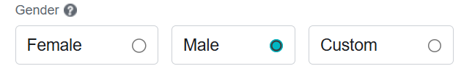
Now if I want to select the male check box
//input[@type='radio'][@value='2']

# Using contains() method = Contains method allow you partially
//tag[contains(@attribute, 'partial_value')]
Ex -
//a[contains(text(),'Already have an account?')]# Using test() method



# Using text Method = Test() methdod cant allow you partially.
Syntax of text method = //tag[text()='Exact text']

Ex = //div[text()='Create a new account']

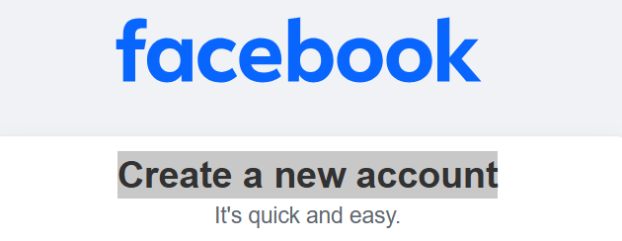

Note - Instead the tagname //div we can also used //* that means it will find the test or value inside the all tags and allow check that how any tags are present the the page
OR in place of tag name we can use Astrick(*)
So there is 166 tags in this page

Que – What is the different between FindElement Vs FindElements ?
Ans – #.FindElement() = We can find 1 elements
#.FindElements() = We can find more than 1 elements
#.Click() = To click the webelement
#.sendKey() =Enter data into inputbox
#.isDisplayed() = will check, if web elements is displayed or not web page
#.isSelected() = Will check, if web elements is selected or not on web page
#.isEnabled() = Will check, if web elements is enabled or not on web page
Note = Radio button we can select only one at a time , but checkbox we can select one or more than one
Program
package JavaPackage;
import java.util.List;
import org.openqa.selenium.By;
import org.openqa.selenium.WebDriver;
import org.openqa.selenium.WebElement;
import org.openqa.selenium.chrome.ChromeDriver;
public class RadioButton {
public static void main(String[] args) throws InterruptedException {
System.setProperty("webdriver.chrome.driver",
"C:\\Users\\Gajendra Yadav\\Downloads\\chromedriver-win64\\chromedriver-win64\\chromedriver.exe");
// Launching chrome browser instance
WebDriver driver = new ChromeDriver();
// Maximize the window
Thread.sleep(2000);
driver.manage().window().maximize();
// Launch the browser
Thread.sleep(2000);
driver.get("https://www.facebook.com/");

Thread.sleep(2000);
driver.findElement(By.xpath("//a[text()='Create new account']")).click();
// 1st Way
driver.findElement(By.xpath("//input[@value='1']")).click();
driver.findElement(By.xpath("//input[@value='2']")).click();
driver.findElement(By.xpath("//input[@value='-1']")).click();
//2nd Way Appropriate Approach
List<WebElement> radios = driver.findElements(By.xpath("//label[@class='_58mt']"));
System.out.println("Total Radio Buttons: " + radios.size());
String expResult = "Female";
for(int i = 0; i <radios.size(); i++) {
if(radios.get(i).getText().equalsIgnoreCase(expResult)) {
radios.get(i).click();
System.out.println(expResult + "clicked");
}
}

}
}

Que – How to handle the DROPDOWN in Selenium?
Ans – Ex like any drop down value like day month year
# if select tag is present inside the DOM, we will use select class method as below
1.selectByIndex()
2.selectByValue()
3.selectByVisibleText()

# if selecttag is not present, we can handle dropdown normally

Drop Down handling Program

package JavaPackage;
import java.util.List;
import org.openqa.selenium.By;
import org.openqa.selenium.WebDriver;
import org.openqa.selenium.WebElement;
import org.openqa.selenium.chrome.ChromeDriver;
public class DropDown {
public static void main(String[] args) throws InterruptedException {
System.setProperty("webdriver.chrome.driver",
"C:\\Users\\Gajendra Yadav\\Downloads\\chromedriver-win64\\chromedriver-win64\\chromedriver.exe");
// Launching chrome browser instance
WebDriver driver = new ChromeDriver();
// Maximize the window
Thread.sleep(2000);
driver.manage().window().maximize();
// Launch the browser
Thread.sleep(2000);
driver.get("https://www.facebook.com/");
Thread.sleep(2000);
driver.findElement(By.xpath("//a[text()='Create new account']")).click();
List<WebElement> birthMonth = driver.findElements(By.xpath("//select[@id='month']/option"));
Thread.sleep(3000);
System.out.println("Total DropDown Values :" + birthMonth.size());
birthMonth.get(2).click();
}
}

Dropdown hading program in different ways

package JavaPackage;

import java.util.List;

import org.openqa.selenium.By;
import org.openqa.selenium.WebDriver;
import org.openqa.selenium.WebElement;
import org.openqa.selenium.chrome.ChromeDriver;
import org.openqa.selenium.support.ui.Select;

public class DropDown {

public static void main(String[] args) throws InterruptedException {
System.setProperty("webdriver.chrome.driver",
"C:\\Users\\Gajendra Yadav\\Downloads\\chromedriver-win64\\chromedriver-win64\\chromedriver.exe");

// Launching chrome browser instance
WebDriver driver = new ChromeDriver();

// Maximize the window
Thread.sleep(2000);
driver.manage().window().maximize();

// Launch the browser
Thread.sleep(2000);
driver.get("https://www.facebook.com/");

Thread.sleep(2000);
driver.findElement(By.xpath("//a[text()='Create new account']")).click();

// 1st way

List<WebElement> birthMonth = driver.findElements(By.xpath("//select[@id='month']/option"));
Thread.sleep(3000);
System.out.println("Total DropDown Values :" + birthMonth.size());
birthMonth.get(2).click();

// 2nd way

WebElement bm = driver.findElement(By.xpath("//select[@id='month']"));
Select month = new Select(bm);
Thread.sleep(3000);
month.selectByVisibleText("Apr"); // Apr
Thread.sleep(3000);
month.selectByValue("12"); // Dec
Thread.sleep(3000);
month.selectByIndex(7); // Aug

System.out.println(month.getFirstSelectedOption().getText()); // Aug -current selected value

// 3rd way

List<WebElement> dropdown = month.getOptions();
System.out.println("Total Dropdown values: " + dropdown.size());
for (int i = 0; i < dropdown.size(); i++) {
if (dropdown.get(i).getText().equalsIgnoreCase("sep")) {
dropdown.get(i).click();
}

}

// 4th Way

Thread.sleep(3000);
driver.findElement(By.xpath("//select[@id='month']")).sendKeys("Nov");

}
}

Que – what is Implicit wait, Explicit wait
Ans –
# Implicit Wait - it is used to check if web elements is located inside DOM/WebPage.
Implicit can be use only once but explicit wait can use as many times as we want
# Explicit wait – it is known as conditional wait

While searching any thing in google the position will not fixed below is the search example snapshot
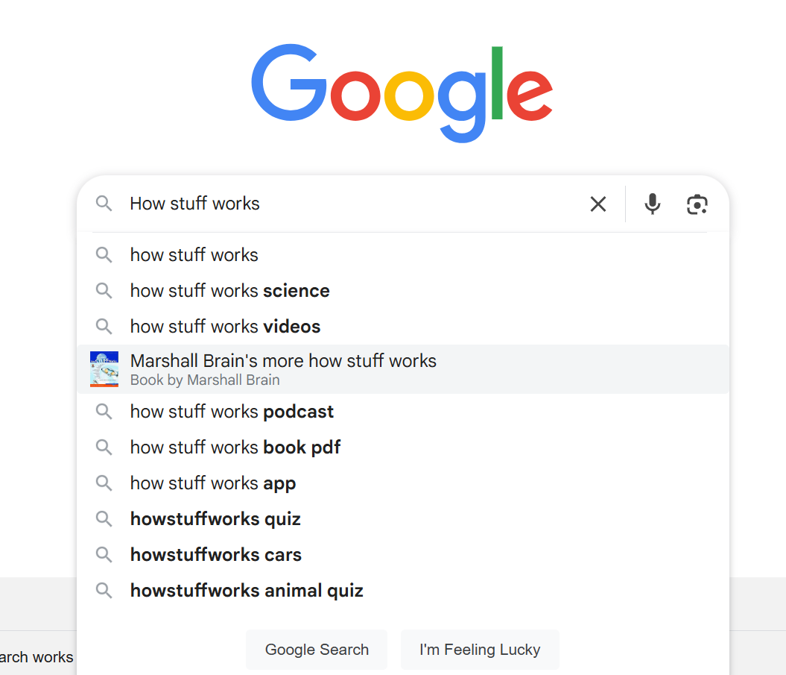

Implicit wait Program

package JavaPackage;

import java.util.List;
import java.util.concurrent.TimeUnit;

import org.openqa.selenium.By;
import org.openqa.selenium.WebDriver;
import org.openqa.selenium.WebElement;
import org.openqa.selenium.chrome.ChromeDriver;

public class ImplicitWait {

public static void main(String[] args) throws InterruptedException {

System.setProperty("webdriver.chrome.driver",
"C:\\Users\\Gajendra Yadav\\Downloads\\chromedriver-win64\\chromedriver-win64\\chromedriver.exe");

// Launching chrome browser instance
WebDriver driver = new ChromeDriver();

// Maximize the window
driver.manage().window().maximize();

// Launch the browser
driver.get("https://www.google.com/");

//Thread.sleep(30000) -- Always it will wait for 30 seconds - not recommended
driver.manage().timeouts().implicitlyWait(30,TimeUnit.SECONDS);
driver.findElement(By.xpath("//textarea[@name='q']")).sendKeys("How stuff work");

// Handle Auto suggestions
List<WebElement> allsuggestions = driver.findElements(By.xpath("//ul[@role='listbox']/li"));
System.out.println("Total element found : " + allsuggestions.size());

for(int i = 0; i < allsuggestions.size();i++) {
String expResult = "How stuff works science";
if(allsuggestions.get(i).getText().equalsIgnoreCase(expResult)) {
allsuggestions.get(i).click();
break;
}

}

}
}

Que – What is testNG ?
Ans – testNG is a popular testing framework in java it provides various types of annotations to configure and manage the test lifecycle
# it always go from outermost to innermost
<suite> <test> <class> <method> <test>

✅ Basic TestNG Annotations
Annotation | Description
@Test | Always knows for testcases
@BeforeMethod | Runs before each test method.
@AfterMethod | Runs after each test method.
@BeforeClass | Runs once before the first test method in the current class.
@AfterClass | Runs once after all test methods in the current class.
@BeforeTest | Runs before any test method belonging to the classes inside <test> tag.
@AfterTest | Runs after all test methods in the <test> tag are run.
@BeforeSuite | Runs once before all tests in the suite.
@AfterSuite | Runs once after all tests in the suite.
@BeforeGroups | Runs before the first test method of a specified group is invoked.
@AfterGroups | Runs after all the test methods of a specified group are invoked.

TestNG Assertions =
#assertTrue(condition) = condition should be true
#assertFalse(condition) = condition should be false
#assertEquals(condition) = condition should be equal

Step-by-Step Guide to Install TestNG in Eclipse
🔹 Step 1: Open Eclipse IDE
Make sure you have Eclipse installed (preferably the latest version).
🔹 Step 2: Install TestNG Plugin
- Go to Help > Eclipse Marketplace...
- In the Eclipse Marketplace dialog, search for "TestNG".
- Click Install next to the TestNG for Eclipse plugin.

Que – What is Maven ?
Ans- Apache Maven is a build automation and project management tool.

🔄 How Maven Helps You:
- No need to manually download and configure JAR files.
- Simplifies project setup and version control.
- Helps manage complex builds and multi-module projects.

✅ 1. Implicit Wait vs. Explicit Wait – Key Differences
Feature | Implicit Wait | Explicit Wait
📍 Applies To | All elements globally | Specific element(s) with specific condition(s)
🕒 Wait Behavior | Waits for a fixed time if element isn’t found | Waits until a condition is met (e.g. visible, clickable)
⚙ Configuration | Set once globally | Set every time you need a specific wait
🎯 Use Case | Simple pages with predictable load times | Dynamic pages with AJAX, animations, or slow responses
🛠 Syntax Simplicity | Simple – one line setup | Requires more code (WebDriverWait + condition)
⛔ Limitation | Can’t wait for conditions like clickable, visible | Can wait for specific conditions
💡 Efficiency | May wait unnecessarily if element is already loaded | Waits only until the condition is true (more efficient)

Que - Mouse And KeyBoard Simulation ??
And - # we can do it through the actions class methods
# After execution we shall use build.perform
Que -Handling Popup, new tap , new window?
Ans -

----------------------------Banking Part------------------------------

Foir = fixed obligation to income ratio
Foir % = total obligation / net monthly income * 100
if Foir % more than 40 % that means foir will be consider as good

What Is Included in FOIR?
✔ Included:

Existing EMIs (Home loan, car loan, personal loan)

1.Proposed loan EMI
2.Rent (in some cases)
3.Credit card minimum dues

LTV = Loan to value ratio
( Formula of LTV )= Loan amount / Property value *100

Broken Period - Only the interest is charged during the broken period; principal is not considered or repaid during this time

Knock Off - Knock is used for adjusting and settlement against the pending dues and outstanding payment Ex- like interst principle

What is Rescheduling in Loans?
1. Tenure Extension
2. EMI Restructuring
3. Moratorium (Payment Holiday)
4. Interest Rate Restructuring
5. Balloon Repayment Rescheduling
6. Step-Up / Step-Down Repayment Rescheduling
7. Restructuring Due to Loan Settlement

1. Tenure Extension
What it means: Increasing the repayment period.
Effect: EMI reduces, but total interest paid increases.
Used when: Borrower is struggling with current EMI amount.
📘 Example: Loan tenure extended from 5 years to 7 years to reduce monthly burden.

2. EMI Restructuring
What it means: Changing the EMI amount by altering tenure or interest rate.
Can be:
Increased (if borrower’s income has improved)
Reduced (if facing hardship)
📘 Example: EMI reduced from ₹10,000 to ₹7,000 by extending the loan tenure.

3. Moratorium (Payment Holiday)
What it means: Temporary pause on EMI payments.
Interest still accrues, but no EMI is required during the moratorium.
Common during: Job loss, natural disasters, medical emergencies.
📘 Example: 3-month moratorium offered during COVID-19 pandemic.

4. Interest Rate Restructuring
What it means: Changing the interest rate (either fixed or floating).
May involve:
Lowering the rate to ease EMI burden
Switching from fixed to floating rate (or vice versa)

📘 Example: Changing from 12% fixed to 9% floating rate.

5. Balloon Repayment Rescheduling
What it means: Smaller EMIs during the loan term and a large lump-sum payment at the end.
Useful when: Future cash inflow is expected (e.g., maturity of investment).
📘 Example: EMI of ₹5,000/month and a final balloon payment of ₹1,00,000.

6. Step-Up / Step-Down Repayment Rescheduling
Step-Up: EMIs increase gradually over time (as income is expected to grow)
Step-Down: EMIs decrease over time (e.g., nearing retirement)
📘 Example: EMI starts at ₹6,000 and steps up to ₹10,000 in 3 years.

7. Restructuring Due to Loan Settlement
What it means: A borrower unable to repay the full amount negotiates new terms — often paying a lump sum that is less than the total outstanding.
Part of the balance may be waived off.
Loan is marked as settled, not fully repaid.
📘 Example: Outstanding ₹2 lakh settled at ₹1.5 lakh.

✅ 1. Receipt
A receipt refers to any payment received by the lender from the borrower.
🔁 In Loan Context:
It could be:
EMI payment
Part-payment (towards principal)
Full repayment (foreclosure)
Late fees or charges paid
📘 Example:
Borrower pays ₹10,000 EMI on the due date.
LMS records a receipt of ₹10,000 against that loan account.
🔍 Purpose:
To reduce the outstanding loan balance
To update repayment history
To track cash inflow to the lender

✅ 2. Refund
🔹 What is it?
A refund means the lender returns money to the borrower, usually due to overpayment, loan cancellation, or error.
🔁 In Loan Context:
Refunds may be processed when:
The borrower pays more than required
A loan is cancelled after disbursement

Duplicate payment is made
Loan is foreclosed, and extra interest was charged
Insurance premium or processing fee is reversed
📘 Example:
Borrower paid ₹15,000 by mistake instead of ₹10,000 EMI.
The lender refunds ₹5,000 to the borrower.
🔍 Purpose:
To correct overpayments or system errors
Ensure transparency and borrower trust

---------------------------RESTASSURED----------------------------------

RESTASSURED

Day 1
Rest assured is an api library through which we can automate the restApi's
Pre-Reuisites
1)Java 9+ & Eclipse
2)TestNg For Eclipse (Help > Eclipse Market > Search TestNg and dowwnload)
3)Maven (comes with eclipse)
------------------------------------------------------

Dependencies

rest-assured
json-Path
json-Path
gson
testNg
'scribejava-api
json-schema-validator
XML-schema-validator

------------------------------------------------------
HTTP REQUEST
GET
POST
PUT
DELETE
-------------------------------------------------------
Only below three methods we will use while writing the residual test phases

.given()
in given we will pass the , Content type, set path, add auth, add param, set header, info etc...
.when()
in given we will pass the,
Get
Post
Put
Delete
.then()
in given we will pass the
Validate status code
Extracted Response
Extracted header cookies & Resoponse body
----------------------------------------------------------
getUsers
https://reqres.in/api/users/2

----------------------------------------------------------
postUser
https://reqres.in/api/users

{
"name": "morpheus",
"job": "leader"
}

------------------------------------------------------------
updateUser
https://reqres.in/api/users/2

{
"name": "morpheus",
"job": "leader"
}

----------------------------------------------------------
deleteUser
https://reqres.in/api/users/2
204

-----------------------------------------------------
Program

package Day1; // package name
import org.testng.annotations.Test; // TestNG for running the test
import static io.restassured.RestAssured.*; // Static import allows you to directly use methods like given(), when(), then(), etc.
import static org.hamcrest.Matchers.*; // This brings in Hamcrest matchers, like equalTo(), used for assertions in the .body() and .statusCode() checks.

public class HTTPRequests { // class named HTTPRequests.

@Test // @Test annotation to mark a method as a test case.

void getUser() { //the method getUser() as a test case.
given() // In my case, nothing is set inside given(), so it proceeds with a basic GET request.

.when() //This tells REST Assured when to send the request — and what type of HTTP method to use.

.get("https://reqres.in/api/users/2") // ends a GET request to the URL: https://reqres.in/api/users/2

.then() // This is used to verify the response (also called assertions or validations).
.statusCode(200) // This asserts that the HTTP status code returned is 200 OK.
.body("data.id", equalTo(2)) // This checks the JSON response body, specifically//The field data.id should be equal to 2
.log().all(); //This logs the entire HTTP response to the console: Status code , Header , Body
}
}

Que - RestAssured automation framework development

Ans - Software framework is a structure that you can use to build software/create test
it help to you provide duplicate and redundant code able to focus on writing code specific to the project
1. Readability
2. Maintainability
3. Reusability
the main of framework is to maintained all commonly used project related files
Hybrid Framework
1. Understanding Requirement - functional requirement specification & swagger
2. Rest assured library
3. Design
4. Development
5. Execution and continuous development

RESTASSURE API FRAMEWORK DESIGN

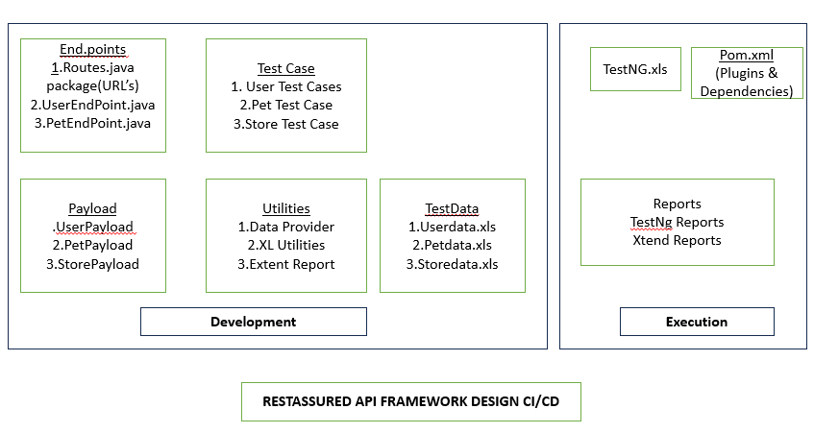

Ques – Reading Properties Files ?
Ans – Properties file having (.properties extension)
#

Que - DEFECT REPORT FORMATE ?
Ans -
Defect Id
Defect Summary
Module Feature Name
Severity
Priority
Environment
Pre-conditions
Step To Reproduce
Expected Result
Actual Result
Attachment
Status

Que - How do you user super keyword in selenium
Ans -Super refers to the parent class
Example : - In a baseTest class having setup() method , we can call it in child test class
Super.setup();

Que -Explain Final finally and fanalize in java
Ans - .Final - Constant variable or method that cannot be overridden
.Finally - Code block that always executes after the try catch
.Finally - Method called by garbage collection before object destruction

Que - How do you read data from an excel file in java selenium
Ans - Using appache POI
FileInputStream fis = new FileInputStream("data.xml");
XSSFWorkbook wb = new XSSWorkbook(fis);
XSSFSheet Sheet = web.getSheet("Sheet");
String value = sheet.getRow(0).getcell(0).getStringCellValue();

Que - What are java collection and where do you use them in selenium
Ans - Collection are java classes for storing groups for objects commonly used :

List : - Store multiple web found by element
set : - Store unique data (e.g, window handles)
Map : - Store key-value (eg. test data mapping)

Que - what are the access modifiers in java and why they are important in selenium framework design?
Ans –
Public :- Accessible from anywhere
Protected : - Access with in the package + Classes
Default :- Access within package only
Private :- Access with in the class only

Importance in Selenium
Use private for webElement variables and public methods for accessing them to maintain encapsulation

Que -How do you handle exceptions in java selenium scripts
Ans --
Try -Catch block :- Handle known exceptions without breaking execution

Try {
driver.findElement(By.id("username")).click();
} catch (NoSuchElementException e) {
system.out.println("Element not found");
}

ThrowsKeyword :- Pass exception handling to the caller
Finally Block :- Executes cleanup code (like closing browser)

Que --What are some limitations of selenium
Ans –
Work only for WebApplications, not desktop app
Cant Handle captcha directly
Required thiord party tools for file uploads in OS popups

Que --How do you run the selenium tests in multiple browsers
Ans --
Use WebDriver instances for each browser
Use TestNG @parameters or dataprovider
User crossprowser testing platform like browserStack

Que - How do you capture the screen shot in selenium

Ans --

File src = ((TakeScreenshot)(driver).getScreenshotsAs(outputType.File);
FileUtills.copyFile(src, new File ("path/screenshot.png"));

Que --What is TestNg and why is it used with selenium
Ans --
TestNg is aframework for java
Advantages :-
Annotations (@Test,BeforeClass, tec)
Parallel test execution
Data Driven Testing
HTML report Generation

Que - What is page object model
Ans --
Page object model is a design pattern that creates object repositories for ui element
advantages :- Code Reusability , Better Readability, Easy Maintenance

Que - How do you handle the changing requirement ?
Ans -
  - Maintain flexible test cases
  - Keep RTM Updated
  - Re-Run impacted test cases
  - Work closely with the product team

Que -How so you test performance for a web app ?
Ans -
- User tool like jmeter and locust
- Measure response time , and throughput errors
- Test under load, stress and endurance conditions

Que - If a bug is not accepted by the developer, how do you convince them ?
Ans -
I follow the professional approach
- EVIDENCE BASED COMMUNICATION – Provide logs, screenshots, api responses, steps to reproduce
- BUSINESS IMPACT – Explain how it affects customer experienceEX – if user can’t apply the coupon, company may loss sales
- DATA DRIVEN APPROACH – Compare behaviour with acceptance criteria ( User story, Requirment Doc’s)

Example: If developer says This is not a bug, it’s by design,” I’d show requirement doc or mockup from BA to prove mismatch. If still not accepted → escalate to QA Lead / Product Owner.

Que - How do you handle a situation where high-severity bug is found just before release?
Ans-
• Immediately inform QA Lead, Dev Lead, Product Owner.
• Show business impact (e.g., payment gateway not working = revenue loss).
• Suggest workarounds if available.
• If fix possible → delay release slightly and retest.
• If no fix → request business decision (release with known bug or block release Example: Found bug: “COD not available at checkout.” → I’d escalate since it blocks 30% of orders.

Oue -How do you handle a failed automation build in Jenkins?
Ans - Check console logs
Identify if failure due to environment script or actual issue.
If script issue - Fix and re-run
If environment – Re-start server and DB/test
If real bugs – Logs in jira

How do you test security in login (e.g., brute force, SQL injection)?
Ans –
• Enter wrong password 5 times → Account locked.
• SQL injection attempt in username → Should sanitize input.
• Check OTP/password encryption.

Que - How do you handle priority vs severity conflicts in bugs?
Ans –
• Severity = impact on system.
• Priority = urgency of fix.

Example:
• Spelling mistake in homepage → Low severity, High priority (customer-facing). • Crash in admin panel → High severity,
Low priority (internal users only).

Que – How do you test api Authentication (0 Auth , JWT )?
Ans –
  - Valid Token – Api Success
  - Expired Token – 401 Unauthorized
  - Tempered Token - Invalid Signature
  - No Token - Blocked

FindElenent returns the first matching element and it through no such exception if no match is found
FindElements returns all the matching elements and it returns the empty list if no matches found
Implicit wait is a global timeout wait
Where explicit what is a specific waits that waits for a certain condition to be true - example like - element to be clickable

what is an exception handling in java
An exception is an unwanted or unexpected event that occurs during program execution (like division by zero, file not found, etc.

Update the existing column
alter table student rename column studentrollno to studentemailid
alter table loandetail rename column studentrollno to studentid
alter table company rename companyemail_id to Companygst_no

SQL Queries

Add a new column

Alter table student add studentempid varchar(100);
alter table student add studentempid varchar(100);
alter table student add studentempid varchar(100)
alter trable student add studentid varchar(200);
alter table student add studentid varchar(300)
alter table student rename column emailed to phone

To add primary key
alter table student add primarykey(studentid);

Select all record from table
Select * from student;

Select specific column from the table
Select name, phonenumber from student;

Count total records in the table
Select count(*) from student;

find record with specific condition
Select * from employee where salary > 3000;
Select * from employee where salary < 3000;

Find record with like operator
Select * from student where name like '%s';
Select * from student where number like '%8';

Sort data using order by
Select * from student order by name desc;
Select * from student order by phone desc;

Select the distinct element form the tale

Select distinct phone from student;
Select distinct username from student;

-----------------------------------------------------------------------------------------------------------------------------------------
Aggregate functions in sql

Select max(salary) from employee;
Select min(salary) from employee;
Select Count(salary) from employee;
Select Sum(salary) from employee;
Select Avg(salary) from employee;

Count Employee in each department
Select department count(*) from employee group by department;

Use having clause to grouped data
Select department Count(*) from employee group by department having count(*) > 5;

--------------------------------------------------------------------------------------------------------------------------------------
Set Operator -
Find the common records

1. Intersect
Select name from student intersect select name from employee;

Find record in one table but not in another
2. Except

Select name from student except select name from employee

------------------------------------------------------------------------------------------------------------------------------------
Data Modification queries

1. Insert data
Insert into student( id , name, email , phone ) values (1 , "jeetu", jeey@gmail.com, 8416846401);

2. Update data
Update student set name = 'arun' where userid = '1';

3. Truncate Table
Truncate table Student;

First/Last Row

Select * from student order by 1 desc limit1;

Delete - delete is used to delete the specific row in the table
Delete from student where studentid = '1';

Truncate - Truncate deletes all the rows from the table but structure remains
Truncate table student;

Drop - drop is used to delete the complete table structure
Drop table student;

